TimeSENS

PANEL LEADER

Quick tour

Summary

Important considerations 1

First login 3

Create a new session 6

Open session 14

Save session 15

Protocol tab 16

Scenario tab 23

Upload tab 43

Monitoring tab 45

Data tab 49

TimeSens for panelists 50

# Important considerations

## Timesens V2 is a WEB APP

**An internet connection is required to create, deploy and access the sessions**.

INRAE disclaims all liability for the quality and electronic transmission of data using telecommunications networks and more generally the quality and reliability of the internet connection between the user device and the software.

**Some functionalities are operating system and browser dependent**. **Recommended browsers** to access the web app as panel leader or panelists are **Chrome** and **Firefox**.

The URL to access the web app is: [**https://www.chemosenstools.com/timesens/panelleader**](https://www.chemosenstools.com/timesens/panelleader)**.**

## Timesens V2 is under development

INRAE provides the Service on an "as is" basis:

**INRAE shall retain all rights, including the right to make updates and corrections, to the software**.

**INRAE has no obligation to provide any technical support and/or maintenance for the software**.

**INRAE does not warrant that the software is exempt from any defect**, but shall use reasonable endeavors to remedy with all reasonable possible diligence any reproducible errors in the software. The user may notify INRAE of any display error, bug or malfunction by writing an email to **chemosenstools@inrae.fr**.

INRAE does not warrant the capability of the software to achieve the objectives or results. **The user is responsible for determining the appropriateness of the software to its needs**, **for the control of its functioning, and for its use**.

**INRAE does not warrant the compatibility of the software with equipment and/or software configuration of the user**.

## AN ACCOUNT is required

INRAE makes available the software by setting up **an account for the user, and providing one login for that account**. **The user is responsible for storing and transmitting the account details** to authorized persons of its choice. **It shall ensure that no unauthorized person has access to the software**.

**If several people share the same account, they will all have access to the same data**. Also, if they work simultaneously on the same session, **any modification made by one person will overwrite the modifications made by the other person**. For these reasons**, it is strongly recommended not to share an account**.

The user may log on at any time, exception planned maintenance or upgrade periods.

## ABOUT THE DATA

Contrarily with TimeSens V1, there is no possibility to work on local files. **All data are stored online, on an INRAE server**. All network transactions between the browser and the server use the **https** protocol.

**The user is solely liable for the contents published and/or downloaded via the software**. **The user shall not store, distribute or transmit any personal data**.

**The data will be stored for a two-months period after the execution of each session**. The user has to download the data before the term of the two-months period, otherwise the data will be erased. **The total volume of data to be stored by the user is limited to 1 GB**. If the volume of data exceeds this limit, the user will be warned that the service will be interrupted until the volume of data will be adjusted.

**INRAE shall not be responsible for accidental destruction of the user’s data by the user** without any fault of INRAE.

## ABOUT THE SOFTWARE

**The software does not comprise the right for the user**:

To copy, duplicate or reproduce all or part of the software, to make reverse engineering, to decompile or disassemble the code of the software or to merge all or part of the software with another software, except if it is expressly authorized by law;

To rent, sell, distribute, lend, convey, transfer, grant a license or sub-license or other rights or share the rights owned by INRAE;

To make available all or part of the software to third parties without prior and written consent of INRAE;

To sell any product or service making available all or part of the software, except for data resulting from the software, without entering into an agreement with INRAE.

## CITING TIMESENS

The software has been registered at the APP (agence pour la protection des programmes). The identification number (IDDN) that was assigned to it, and which tags the software and associated publications, is IDDN.FR.001.080013.002.S.P.2011.000.10000.

**The user agrees to cite INRAE and the software** as follows: "Source: TIMESENS, INRA, CSGA, Dijon", **in any publication, presentation or other work in which the software has been used** to produce or confirm results subject to publication, presentation or work.

# First login

## Authentification

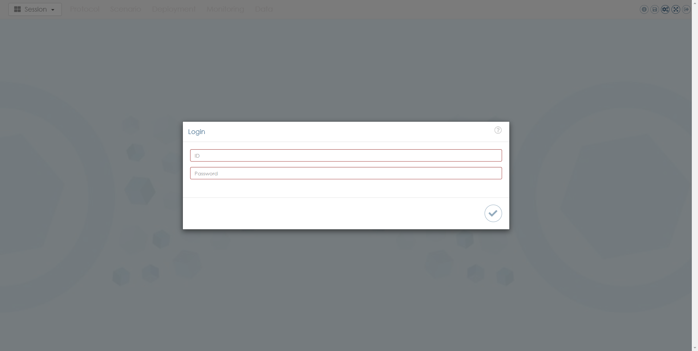

Authentication with login and password is required to access the software.

## Main menu

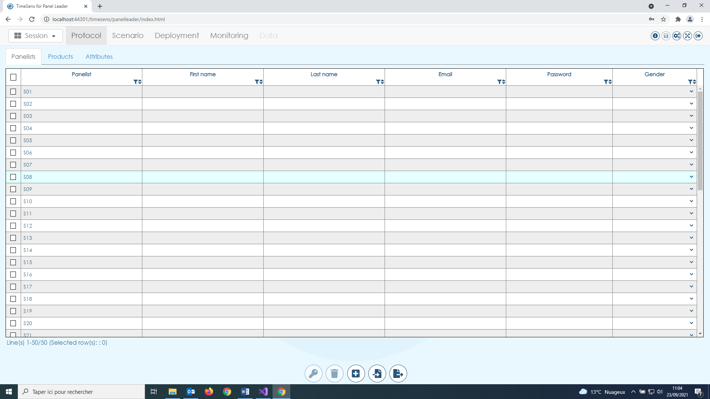

The main menu is made up of 3 parts:

* A dropdown button ("Session") allowing to create, open and save a session
* 5 tabs corresponding to the chronological steps from session definition to data collection
* 5 buttons

The buttons/tabs/actions tab are grayed out when not applicable in the current context.

### Session button

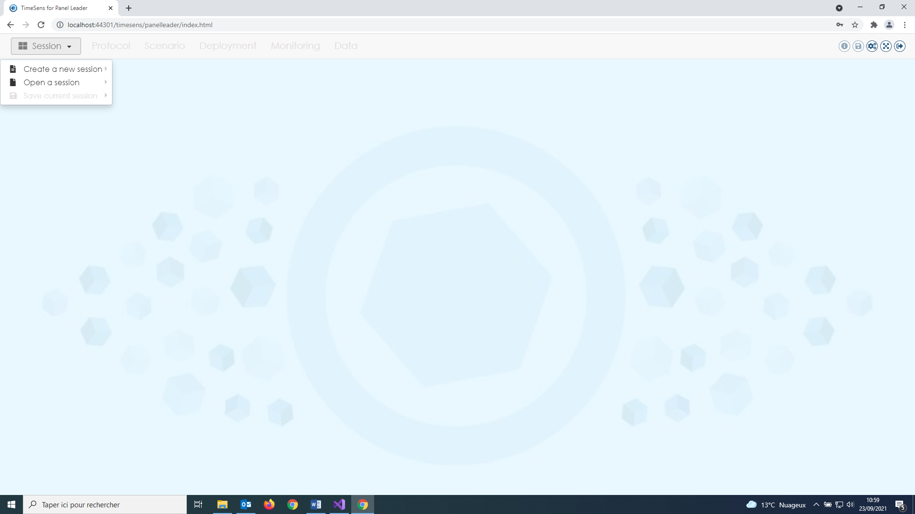

See: "Create a new session", "Open a session", "Save current session".

### Tabs



See: "Protocol tab", "Scenario tab", "Deployment tab", "Monitoring tab", "Data tab".

### Menu buttons



From left to right, click to:

* **display session log (**hover to display the name of the session)
* **save changes** made to the session
* **display settings**
* **switch to full screen mode**
* **log out** (change of user)

The action is grayed out if it is not accessible.

## Session log

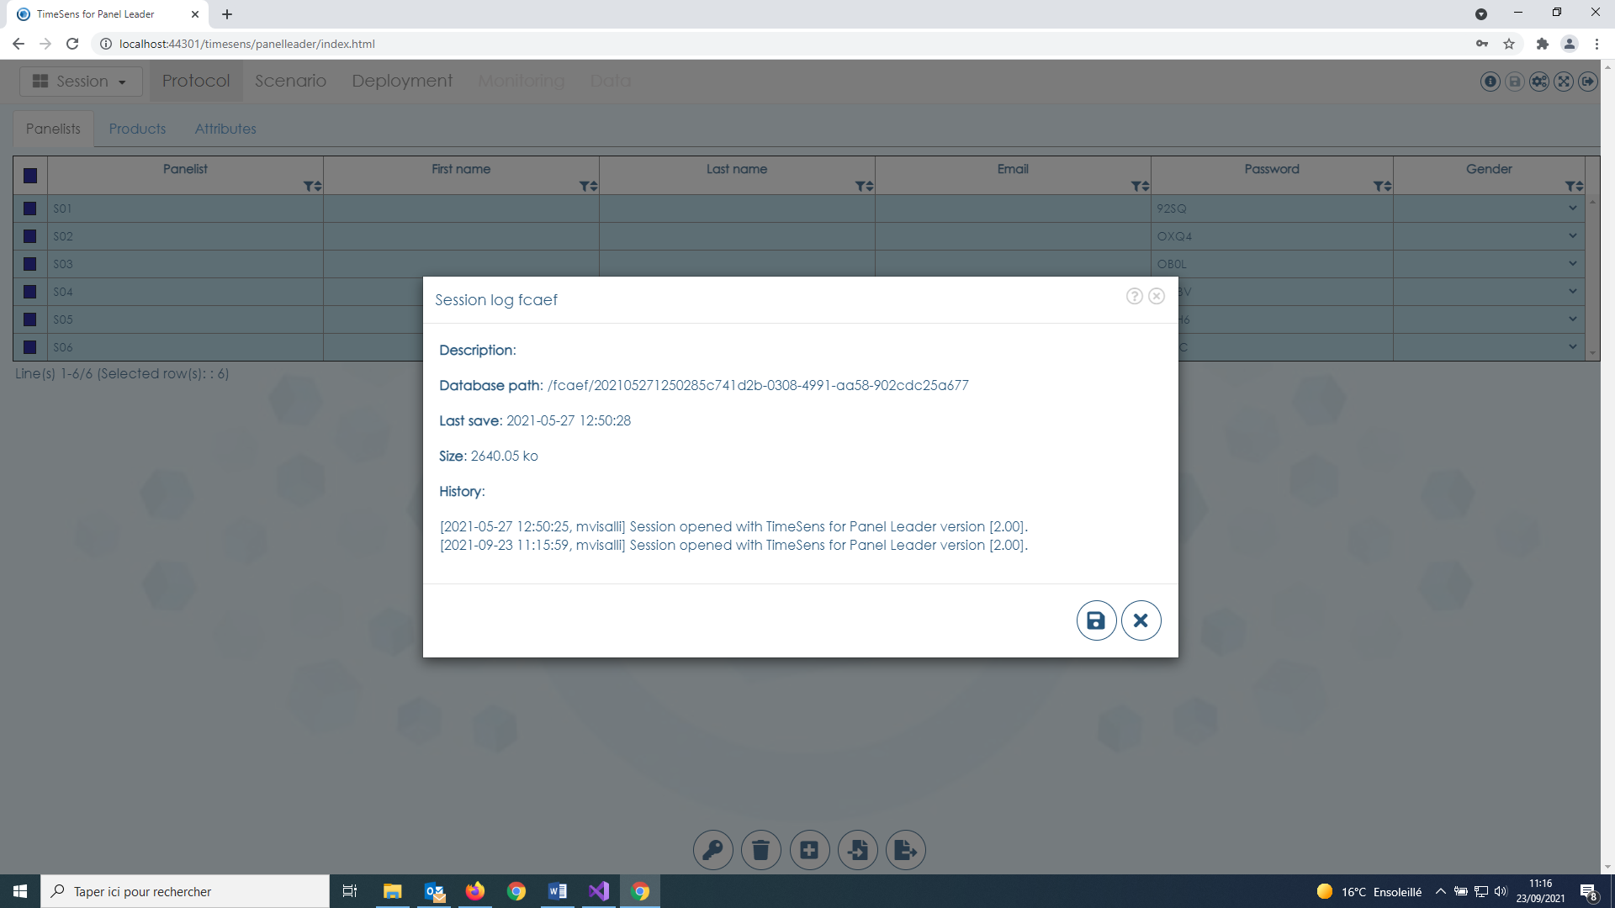

This screen displays information about the session and changes that have been made.

## SETTINGS

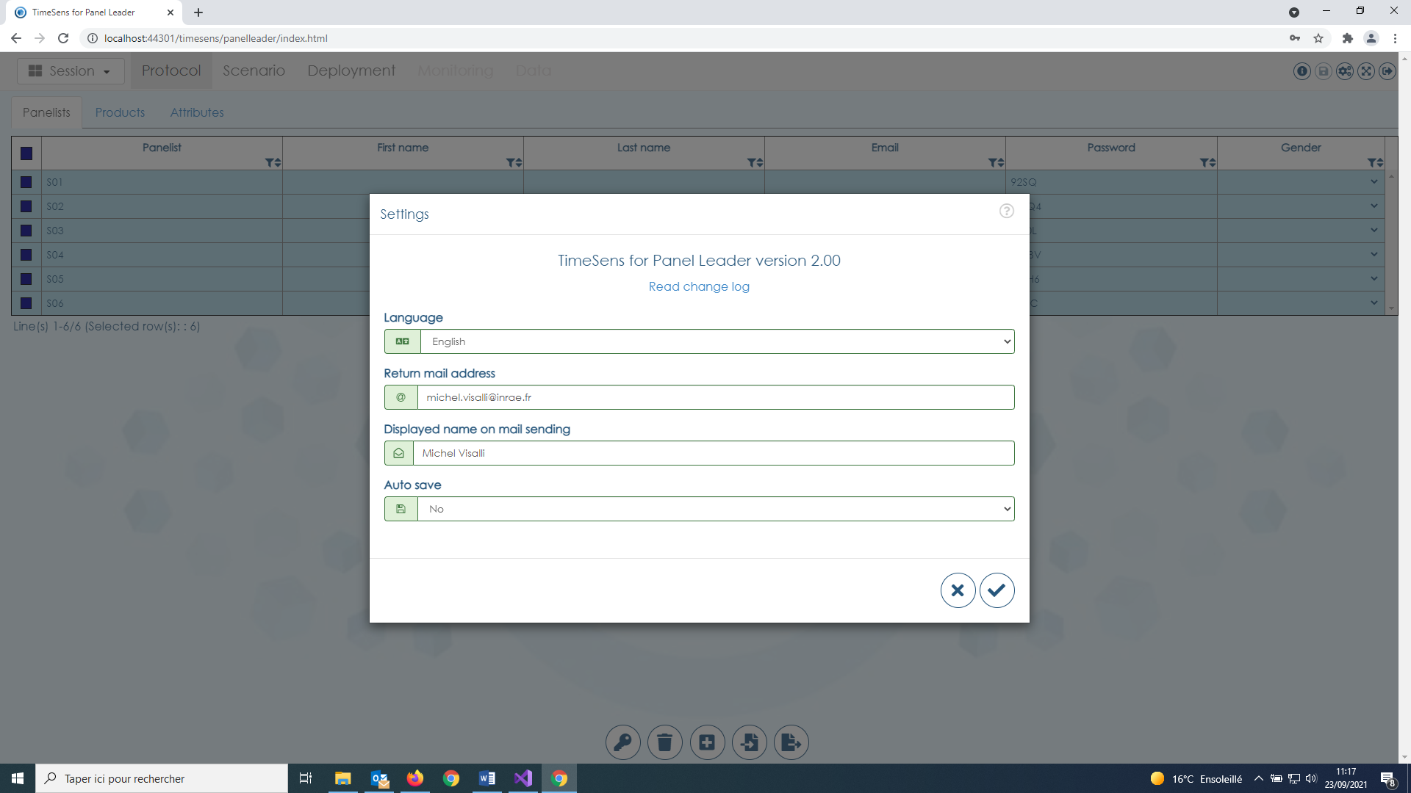

This screen allows to parameter the software:

* **Language**: language of the application
* **Return mail address**: mail address to be used when a panelist replies to a session link.
* **Displayed name on mail sending**: name displayed in the field "from" when a panelist receive a mail
* **Autosave**: if yes, changes applied to the sessions are saved on tab change (default = no, difference with TimeSens V1)

# Create a new session

## FROM archive file

**Open from local disk** **a backup file** with extension ".TS2" and **create a new session**.

**TS2 files are sessions archived on local disk**, and (contrarily with TimeSens V1) **it is not possible to work directly with local files**.

## From wizard

**The session wizard allows a session to be created from a predefined template related to a sensory protocol**.

### Step 1: Template selection

## 

**"Empty session"** allows to create an empty session (not related to a specific sensory protocol).

**"Custom template"** allows to create a session from an existing session (see "From custom template").

All others templates correspond to sensory protocols.

Click on the box corresponding to the chosen template to create a new session, then on the bottom right button to specify protocol options.

### Step 2: Protocol definition

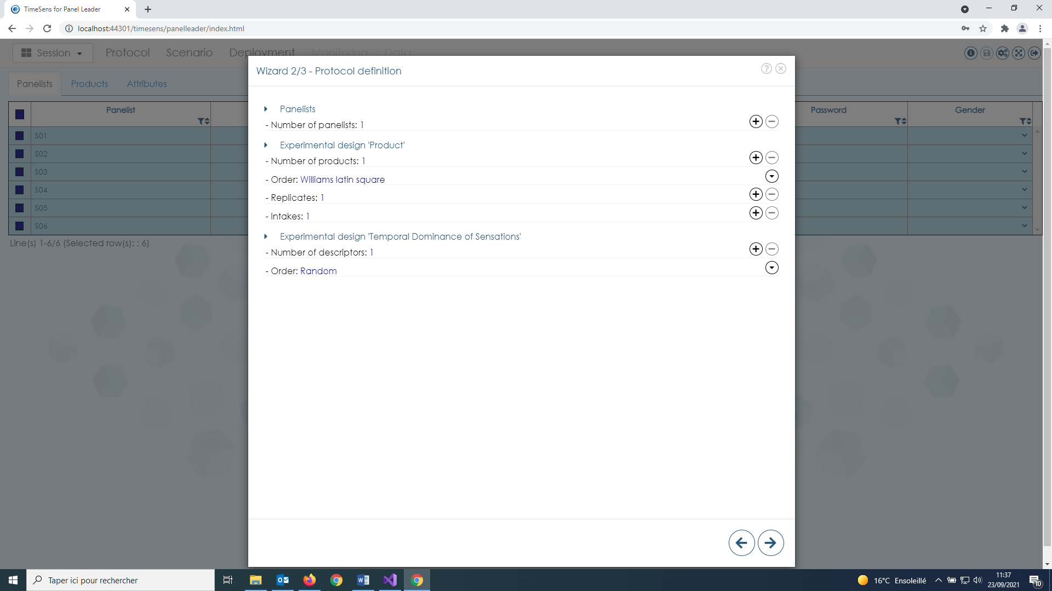

This screen allows to quickly define the protocol:

* The **number of panelists** (they will be created with codes Sxxx)
* The **number of products** (they will be created with codes Pxxx*)
* The **order in which the products will be presented** (related to product experimental design)
* The **number of replicates** for each product**
* The **number of intakes** for each product**
* The **number of attributes** (they will be created with codes Axxx*)
* The **order in which the attributes will be presented** (related to product experimental design)

*Codes can be changed later from the Protocol tab.

\*\***Intakes are presented successively** (P001-P001 then P002-P002 with 2 intakes), **replicates are presented by block** (P001-P002 then P001-P002 with 2 replicates)

### Step3: Screen selection

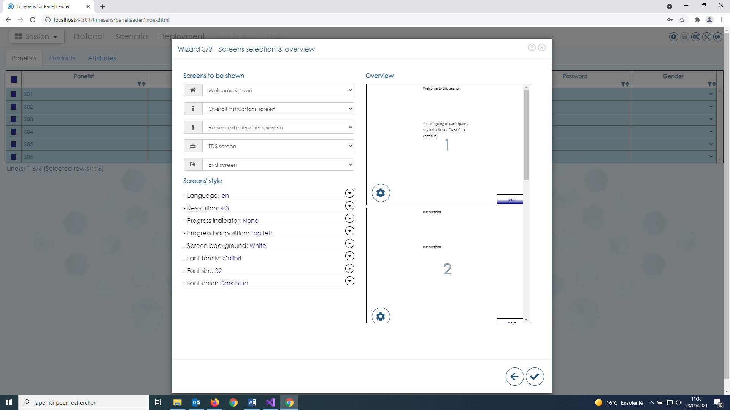

This screen allows to customize the screens that will be displayed.

**Screens to be shown** allows to select the screens to include in the session:

* **Welcome screen**: screen displayed to welcome the panelists
* **Overall instructions screen**: screen displayed to present the study
* **Repeated instructions screen**: screen displayed before each measurement screen
* **Measurement screen**: **screen displayed to collect data, with controls (scale, question, etc.) depending on the sensory protocol, repeated according to an experimental design** (it is the only mandatory screen)
* **End screen**: screen displayed to thank the panelists for their participation

The default texts can be changed in the Scenario tab.

**Screens’ style** allows to define the design of the session:

* **Language**: default language for the default texts
* **Resolution**: resolution of the screen (ratio height/width)
* **Progress indicator**: display the current progress on each screen
* **Progress bar position**: position of the current progress indicator on each screen
* **Font family**: default font family to be used for each text
* **Font size**: default font size to be used for each text
* **Font color**: default font color to be used for each text

The design of the controls can be changed in the Scenario tab.

**Overview** shows a list of miniatures representing the screen as they will be displayed with the selected options. More options, depending on the type of screen, are available by clicking on the button:

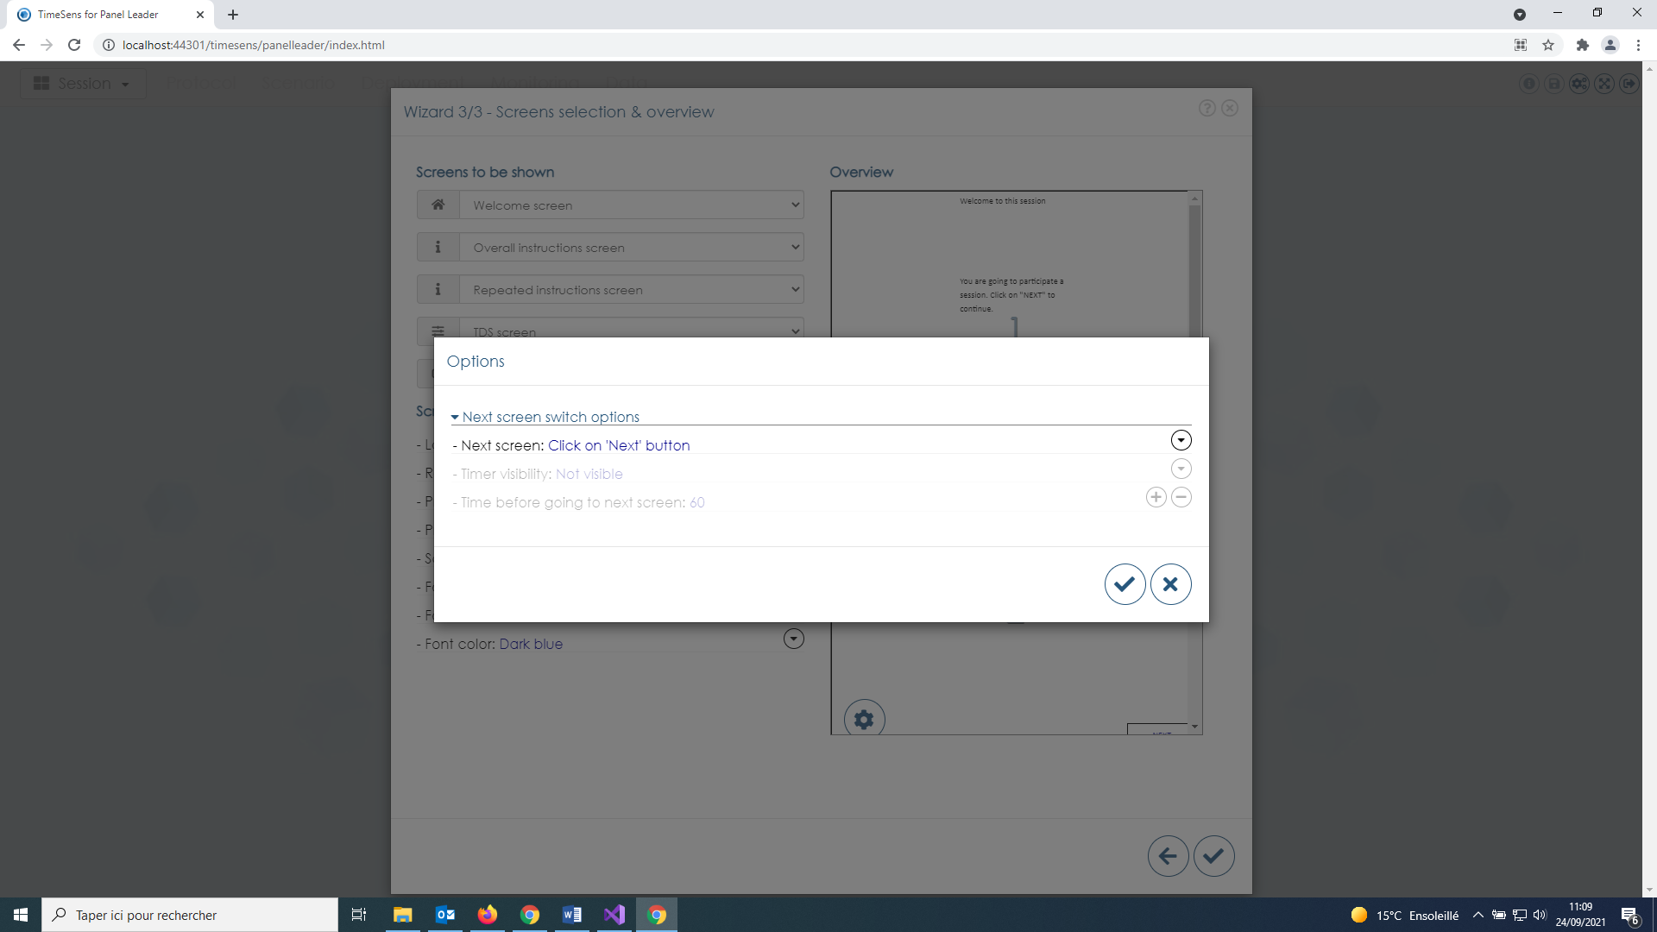

**Next screen switch options**:

* **Next screen**: condition required to go to the next screen (button click or timer)
* **Timer visibility**: visibility of the chronometer associated with the timer (requires Next screen=When timer reaches 0)
* **Time before going to next screen**: duration (in seconds) during which the screen will be displayed before to go on the next screen (requires Next screen=When timer reaches 0)

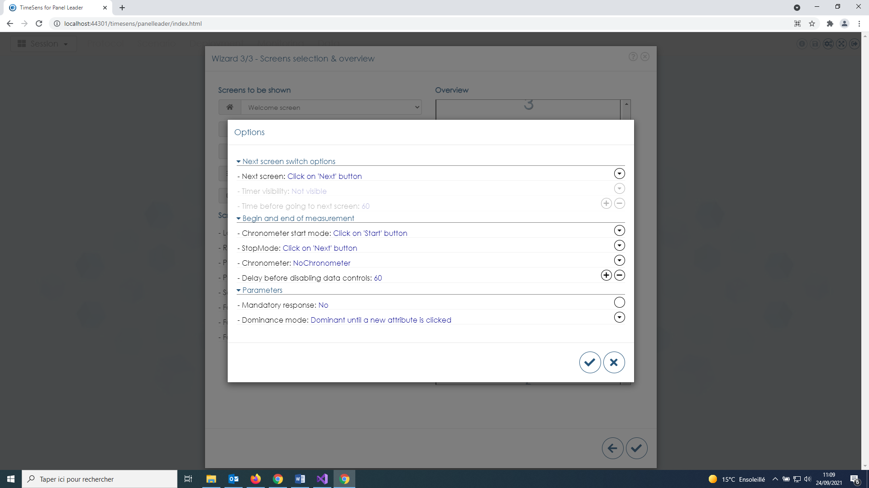

**Begin and end of measurement (temporal measures only):**

* **Chronometer start mode**: moment when time recording begins
* **Stop mode**: moment when time recording stops
* **Chronometer**: add a chronometer* on the screen (visible or not)
* **Delay before disabling data controls**: duration (in seconds) during which the controls will be enabled on the screen (requires Chronometer)

*Chronometer is different from timer, it disables the controls (scales, buttons, etc.)

**Parameters**:

* **Mandatory response**: if yes, the panelists can’t go on next screen if he did not select/score at least one attribute
* **Dominance mode**: definition of dominance used (if sensory protocol = TDS)

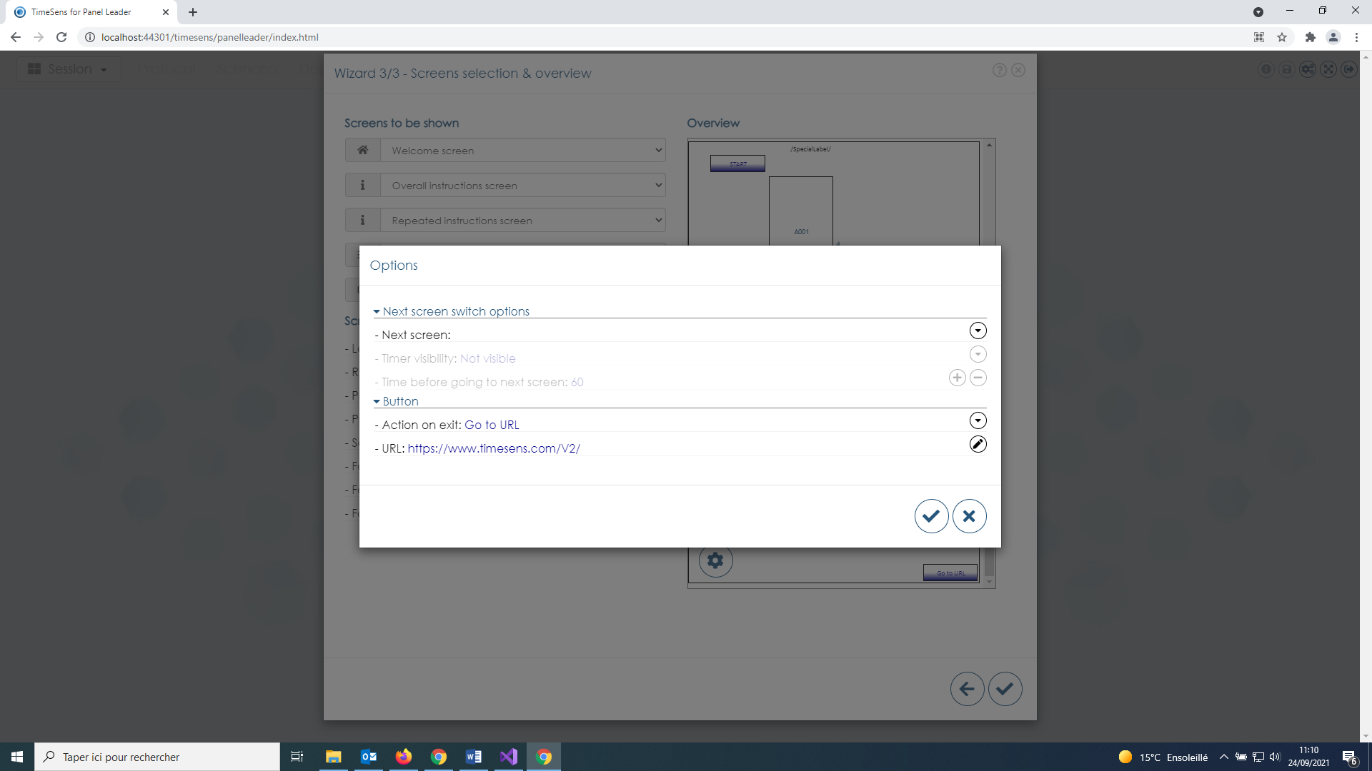

**Button (end screen only):**

* **Action on exit**: action when the panelist clicks on the exit session
* **URL**: URL to redirect the browser of the panelist (requires Action on exit= "GoToURL")

### Save

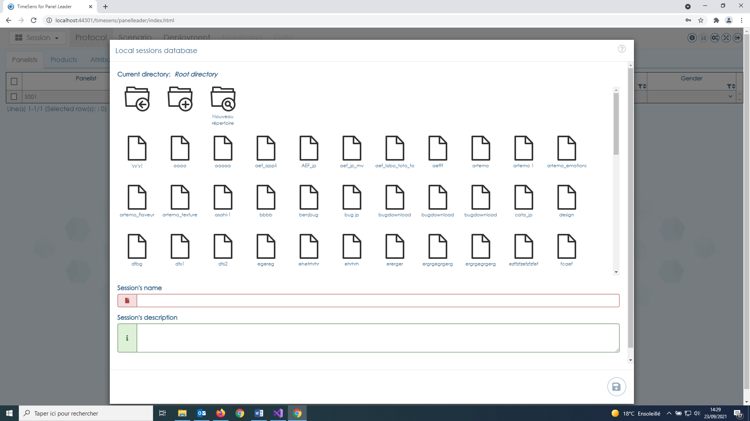

**Once the session is designed, it has to be saved on ChemoSens server**. This screen displays a virtual file system browser **not related to local file system**, **root directory being the dedicated storage relative to the account used to access the software**.

**Session’s name is mandatory (min 4 characters) and has to be unique.**



The buttons, from left to right, allows:

* to **go up one level** in the virtual file system tree
* to **create a new virtual directory**
* to **explore the content of a virtual directory**

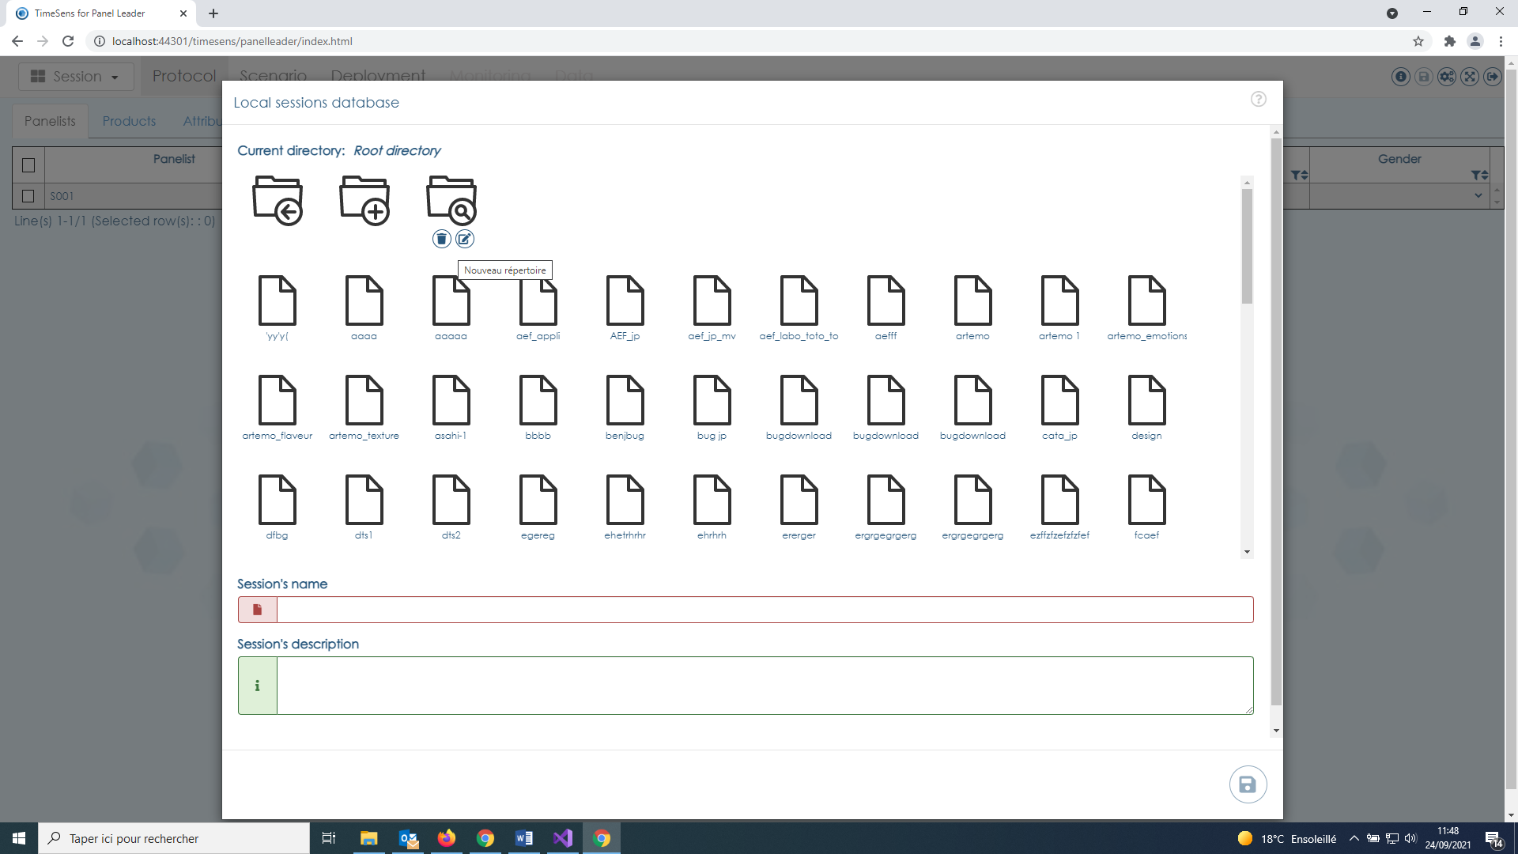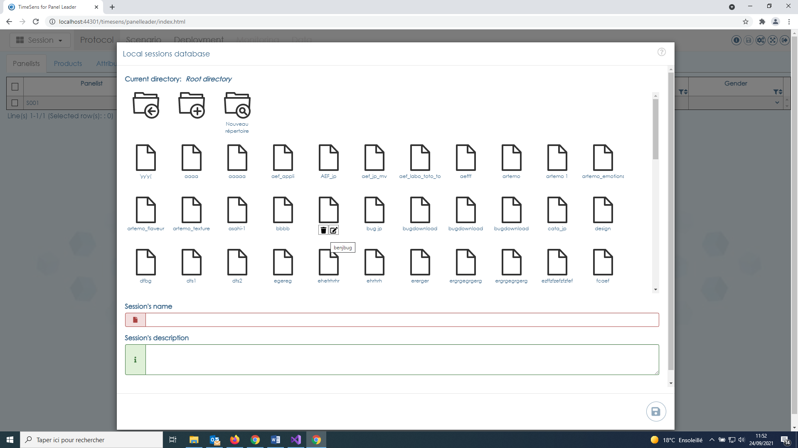

Keeping the **mouse cursor hover the icon of an existing virtual directory or file enables to delete** (left button) or **rename** (right button) the directory/file.

## FROM Custom template

This template allows to **create a session from an existing session**.

Step 1 consists in **choosing an existing session that will serve as a template**. The **subjects, products and attributes will be replaced by those present in a XLSX file** chosen on local disk in Step 2.

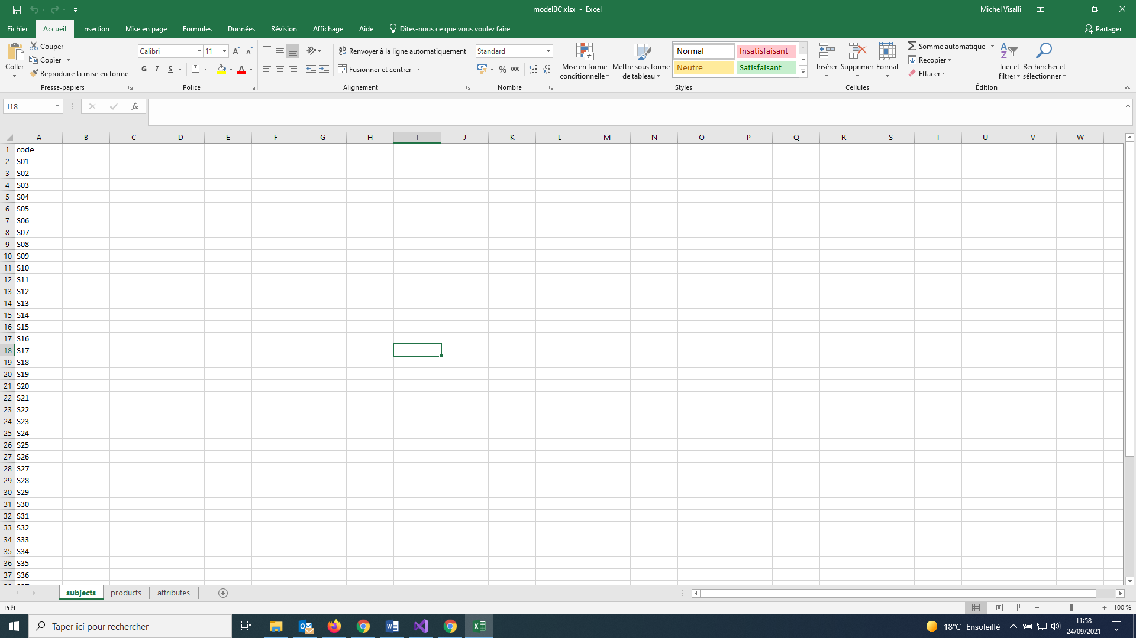 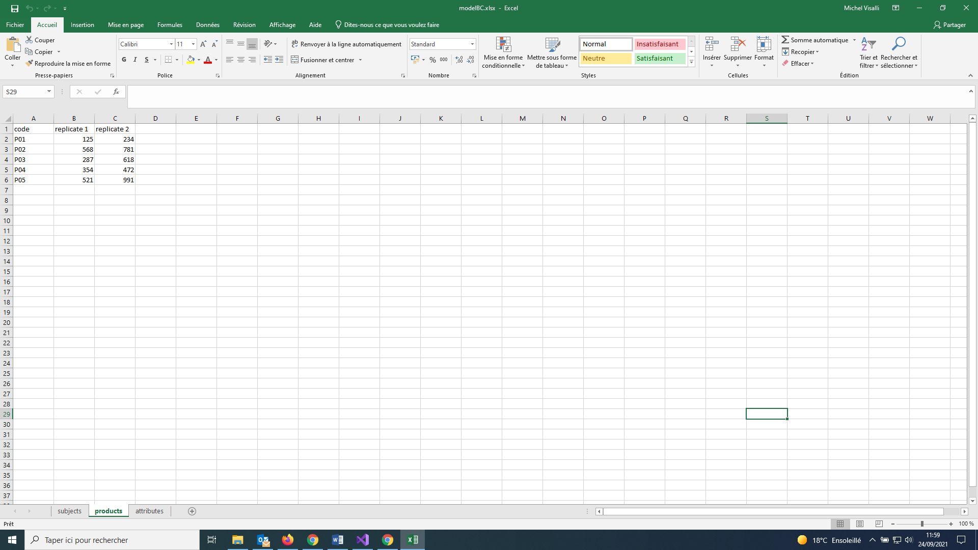 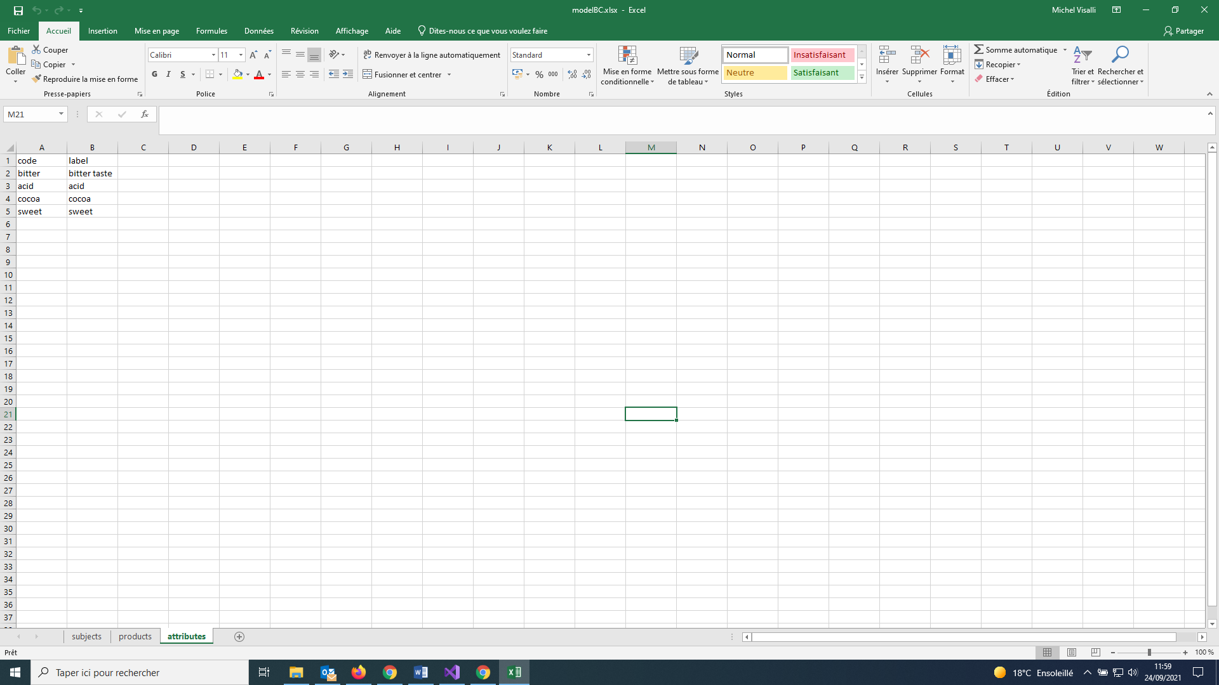

**The XLSX file must have 3 tabs named "subjects", "products" and "attributes"**:

* the "subjects" tab must contain one column named "code", and one row for each panelist
* the "products" tab must contain one column named "code", and as many supplementary columns as the number of replicates (columns named "replicate 1", "replicate 2", etc.), and one row for each product
* the "attributes" tab must contain two columns named "code" and "label", and one row for each attribute

# Open session

**Sessions created with TimeSens V1 are not compatible with TimeSens V2.**

**Reminder: the sessions are stored on ChemoSens server, not on local disks**.

The virtual file system browser relative to the account used to access the software is displayed when "**Open session > From database**" is clicked on the session button.

The last accessed sessions are accessible from "**Open session > Recent sessions**".

# Save session

**Unlike TimeSens V1, changes made to the session are not automatically saved when the user changes of screen.**

## Save

Click on "**Save current session > Save**" (Session button) or on the menu button to save the current session.

## Save as copy

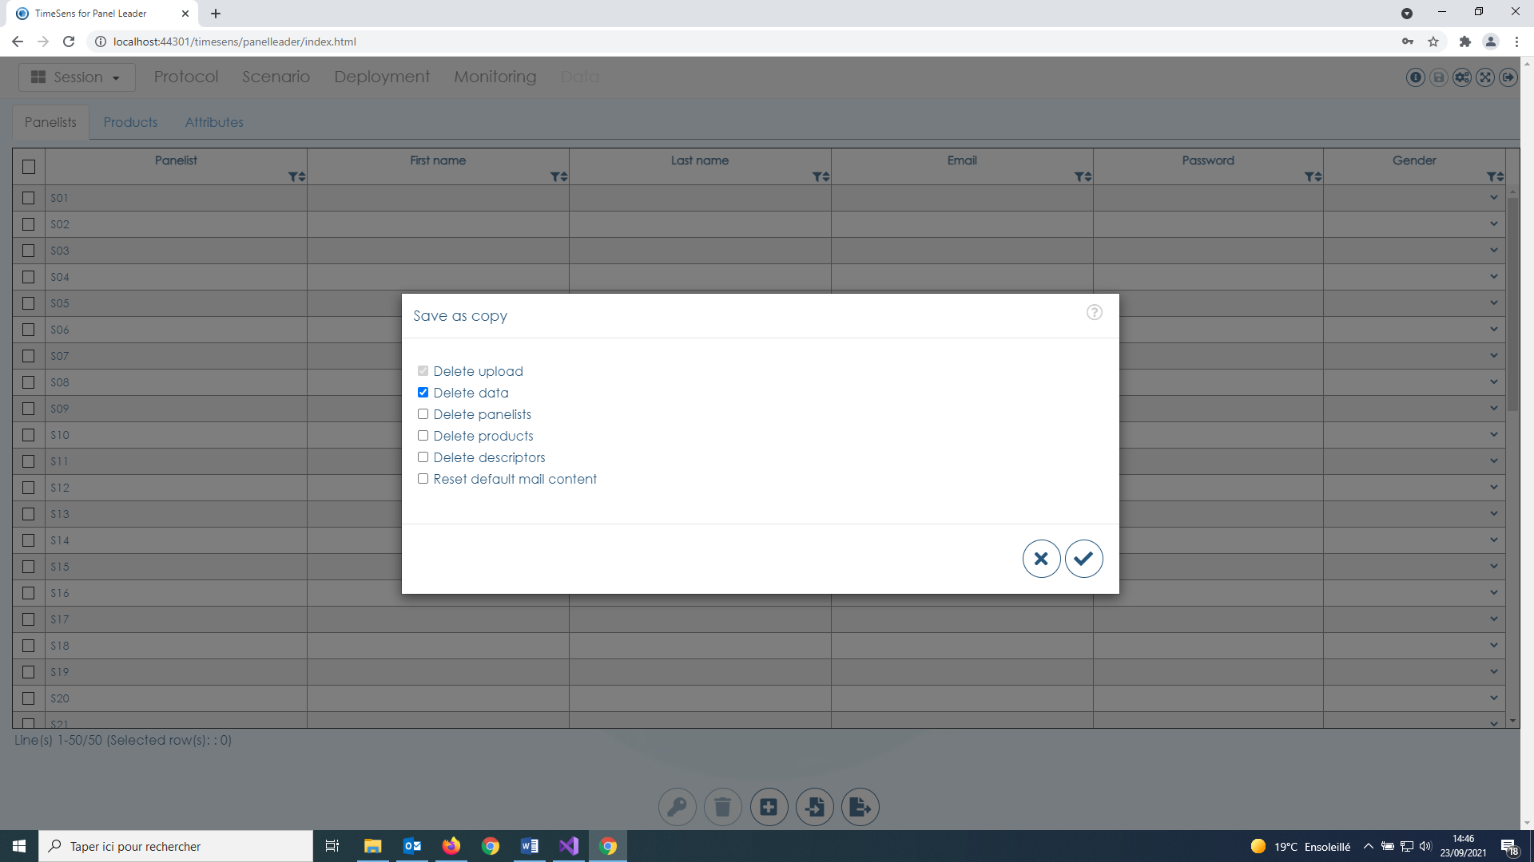

Click on "**Save current session > Save as copy**" (Session button) to save un undeployed copy of the current session. By clicking on corresponding checkbox, it is possible to **delete data, panelists, products, descriptors and default mail content**.

## archive ON local disk

Click on "**Save current session > Archive on local disk**" to save a backup copy of the session on local disk.

# Protocol tab

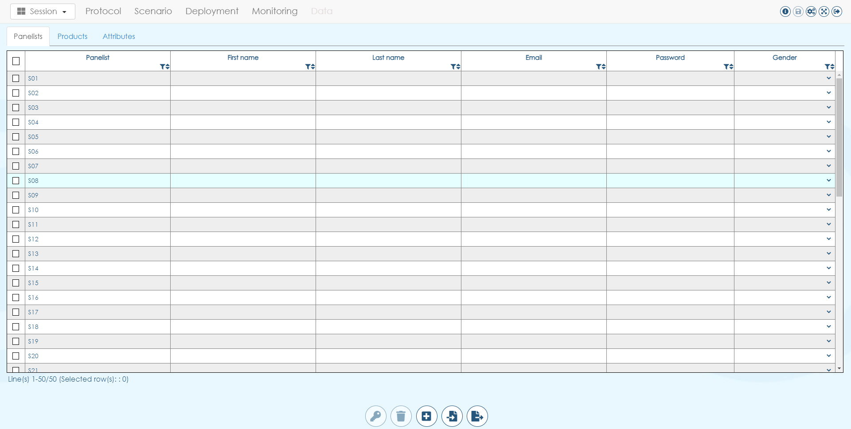

The protocol tab is made of 3 tabs:

* **Panelists**: the panelists that will attend the session and information about them
* **Products**: the products that will be presented to the panelists and the associated product experimental designs
* **Attributes**: the attributes that will be presented to the panelists and the associated attribute experimental designs

Information are presented as data tables. **All data tables can be filtered and/or sorted** using the buttons below the column names:

**All rows can be selected by clicking the checkboxes at left**. The upper left checkbox allows to **toggle the selected rows** in one click.

**Warning: Adding/removing panelists or products can break the structure of an experimental design (for example William’s Latin squares)**. **The orders of presentation should always be verified before the session is deployed.**

## Panelists

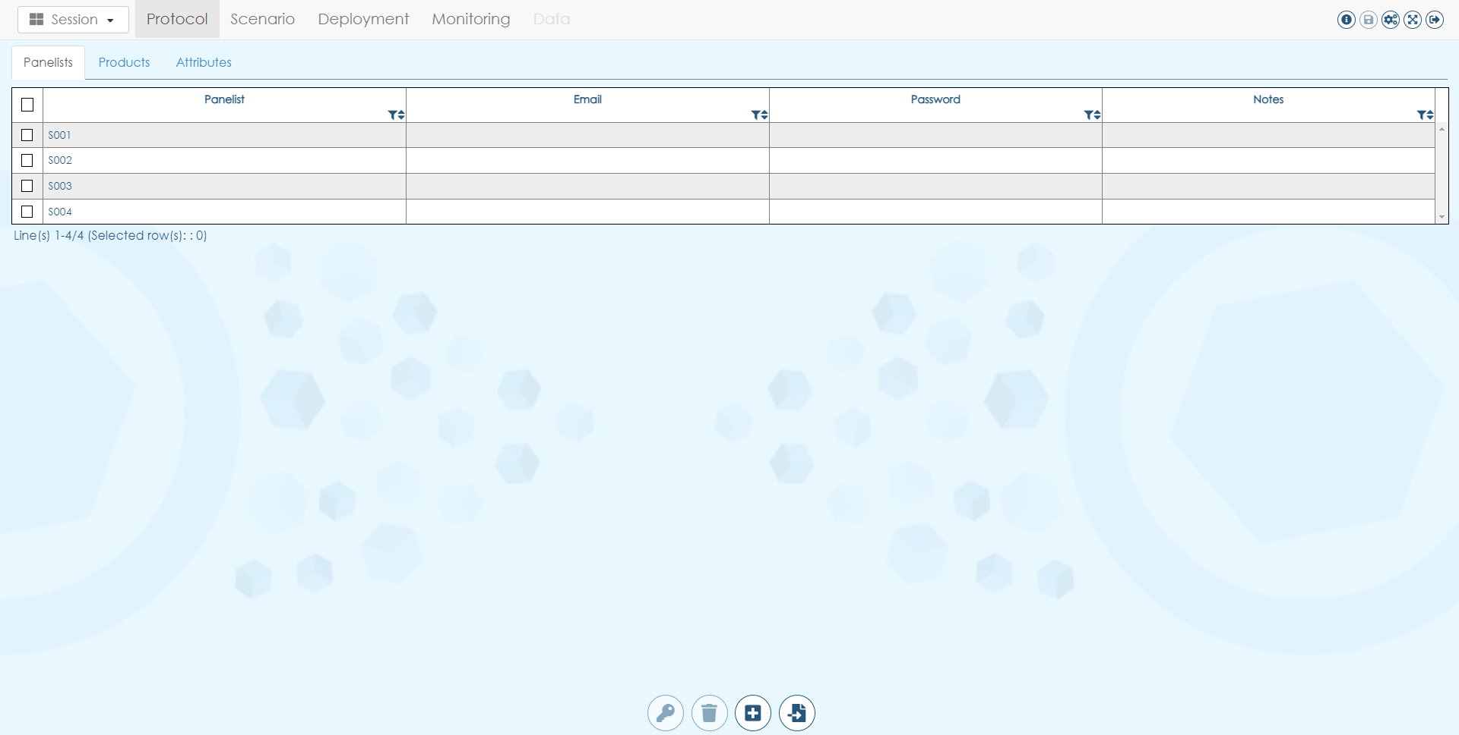

The table contains information about the panelists:

* **Panelist** is the code (unique, with no special character) that will be used to identify the panelist and to access the session
* **Email: remind to remove emails after they have been sent to be compliant with legislation about personal data**
* **Password**

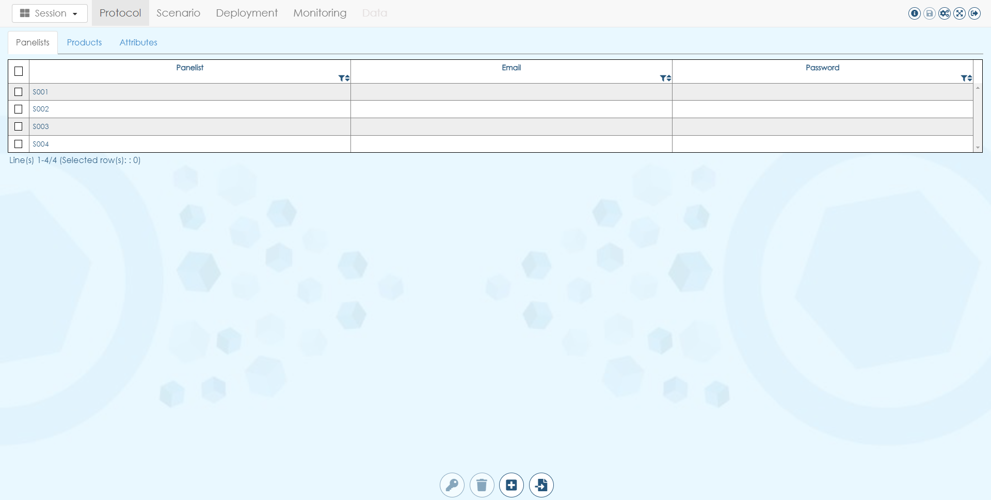

From left to right, the bottom action buttons allow to:

* **Generate passwords** for selected panelists
* **Remove selected panelists** from current session
* **Add new panelists** to current session
* **Import panelists** in current session

### Generate passwords for selected panelists

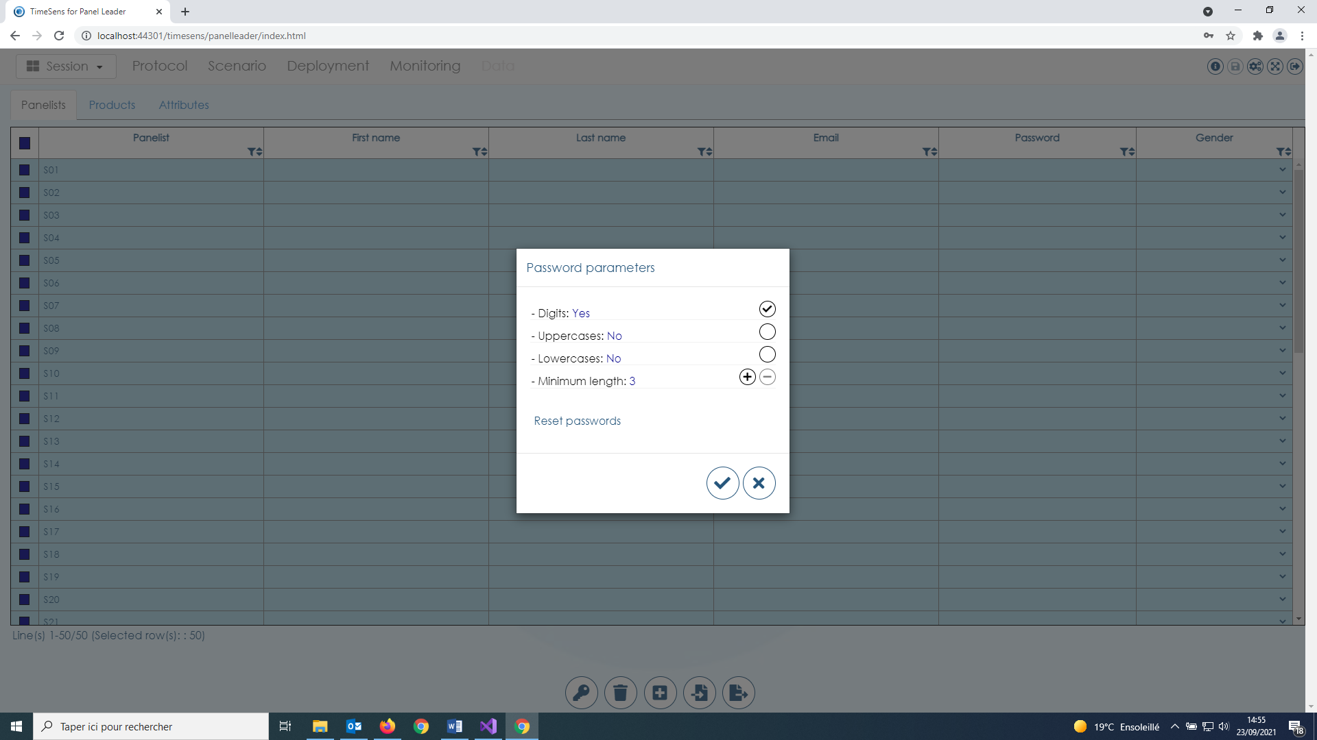

The **passwords can include** or not: **digits**, **uppercase letters**, **lowercase letters**, and they have a **minimum length** (default: 3 digits).

**Reset passwords** allows to reset the passwords for all selected panelists.

### Remove selected panelists from current session

The selected panelists are removed from the session and from the product experimental designs.

### Add new panelists to current session

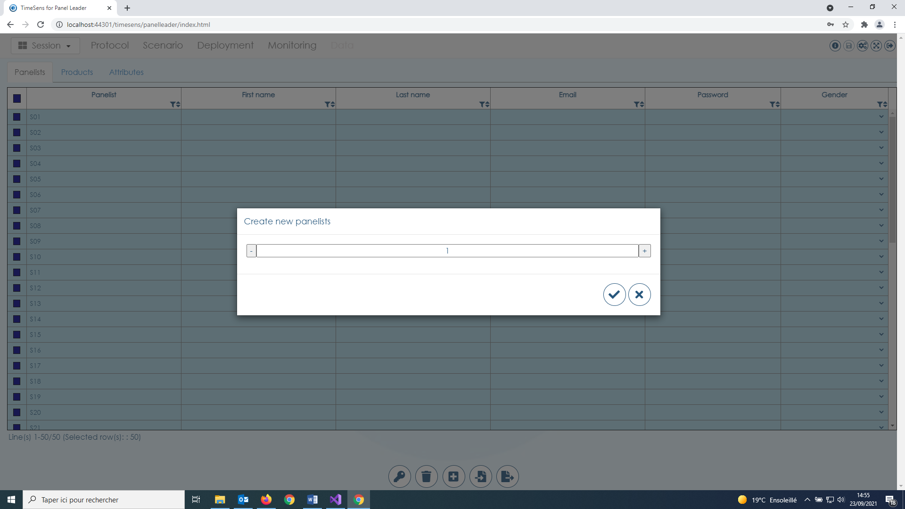

New panelists are created with codes Sxxx, then added the session and to each experimental design.

### Import panelists

Step 1: **Choose file format**

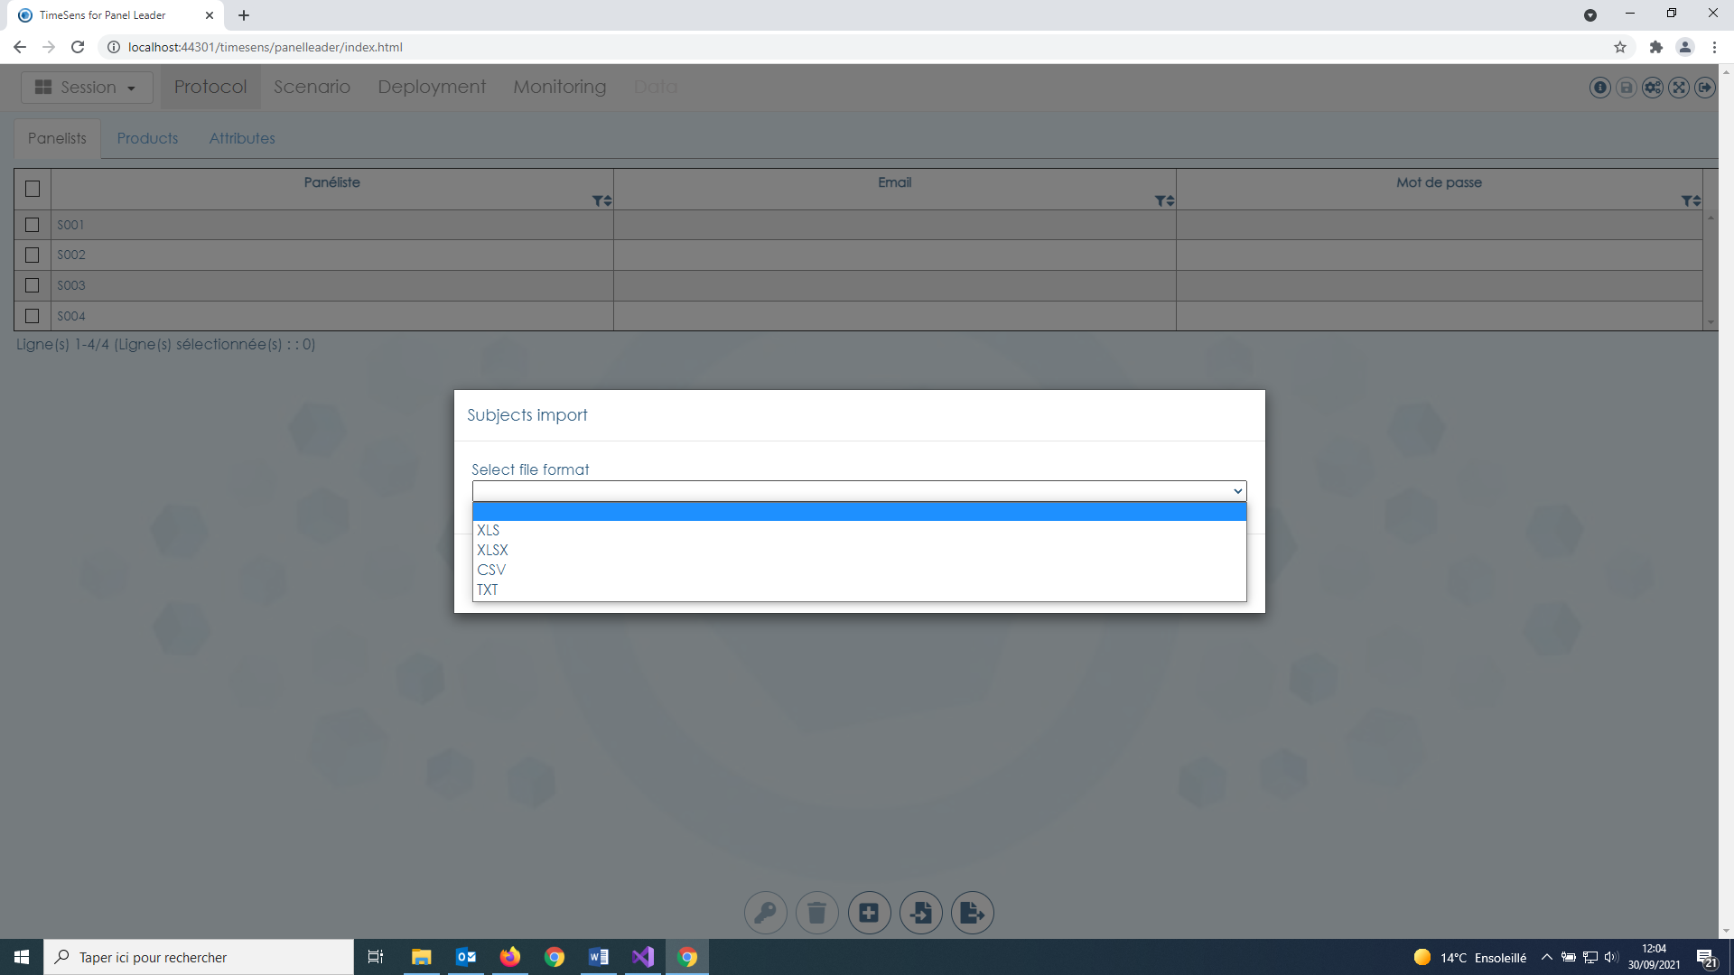

Step2: **Pair imported files columns with expected TimeSens fields** by clicking on [Click to select] in column "Found column name" (mandatory fields are indicated in the last column).

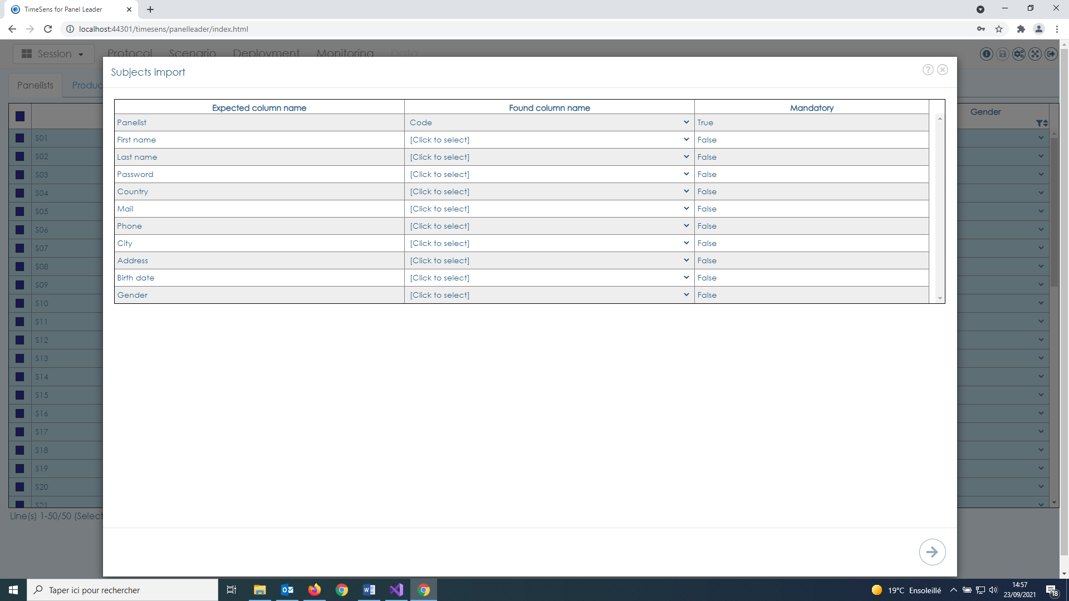

Step3: **Check pairing**

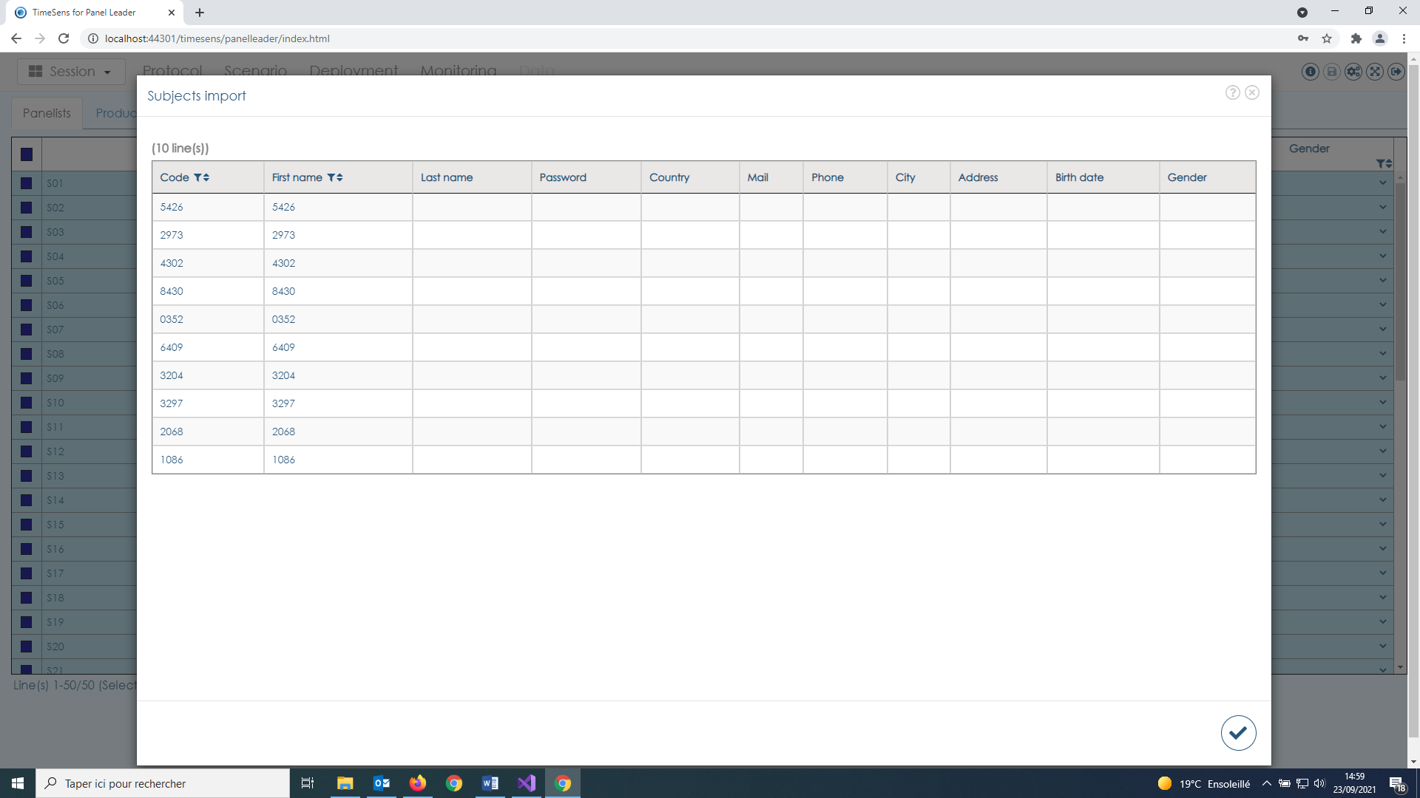

## Products

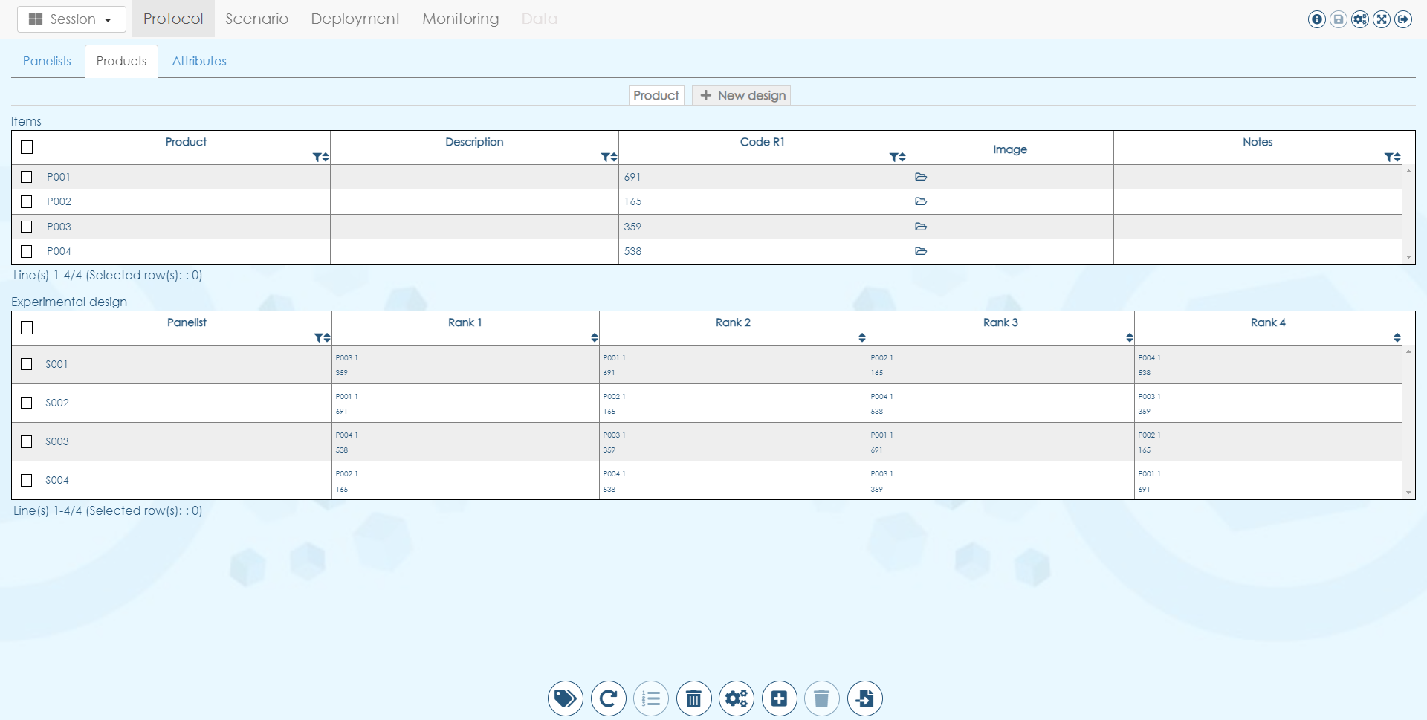

The first table gathers **information about the products**:

* **Product** is the code (unique, with no special character) that will be used to identify the product in the data (not displayed to panelists)
* **Description** is the user-friendly description of the product (not displayed to panelists)
* **Code R1… Code Rx** are the labels displayed associated with each repetition of the product that will be displayed to the panelists
* **Image** corresponds to the image associated to the product (experimental)
* **Notes** is an additional field to store information on the product

The second table presents the **order in which the products will be presented** (one row by subject). The cell related to each rank contains **Product code and replicate** (fist line) and **label** (second line).

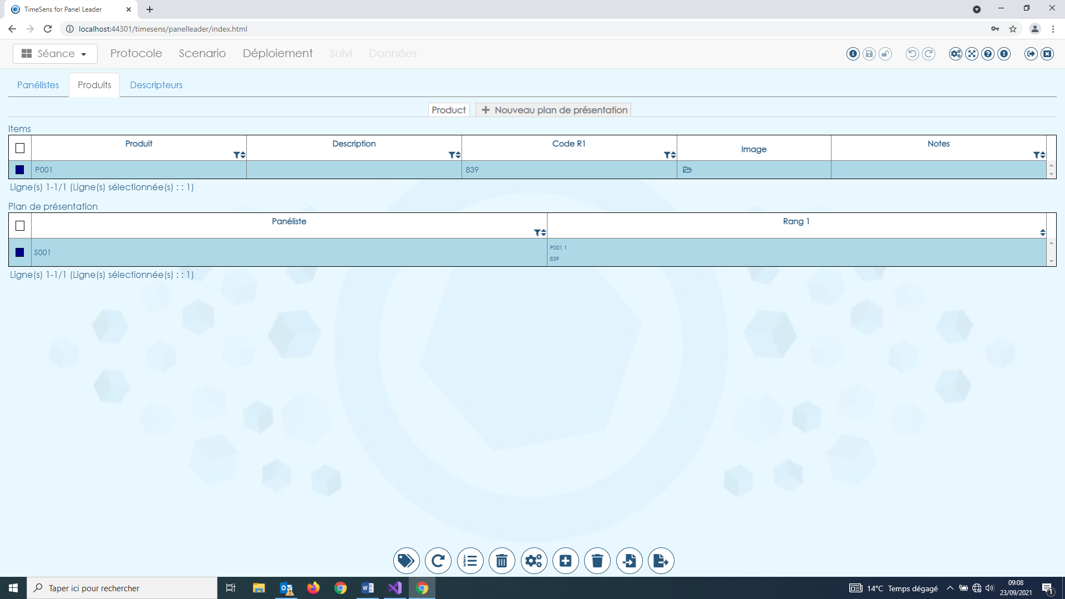

From left to right, the bottom action buttons allow to:

* **Generate new labels** for current design
* **Reinitialize current design**
* **Edit product ranks** for current design
* **Remove current design**
* **Edit current design settings**
* **Remove products from current design**
* **Import product design**

### Generate new labels for current design

The functionality is the same as generating passwords.

### Reinitialize current design

It allows to generate a new design with the same specifications (new orders of presentation).

### Edit product ranks for selected products in current design

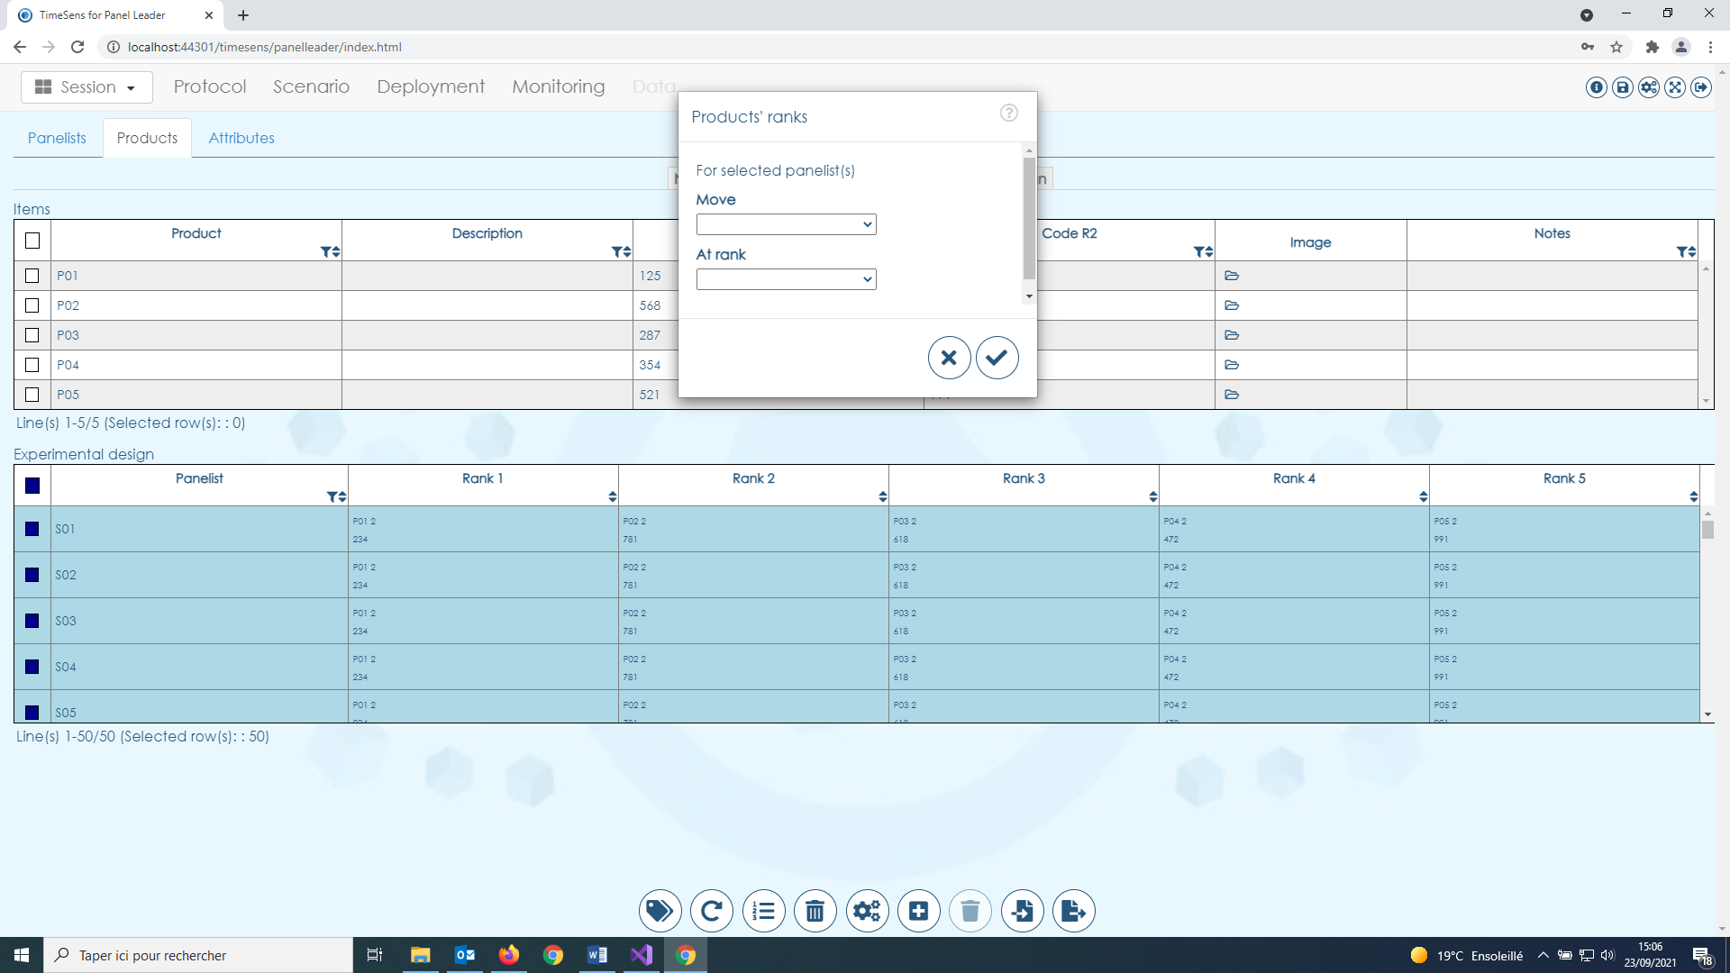

It allows to change the order of presentation of the selected subjects. For example, it is possible to set a warm-up product by selecting all subjects, then moving warmup product at rank 1.

**Warning: these changes can break the structure of the experimental design. The changes are lost if the experimental is reinitialized or changed.**

### Remove current design

The design cannot be removed if it is referenced on a screen in the scenario tab.

### Edit current design settings

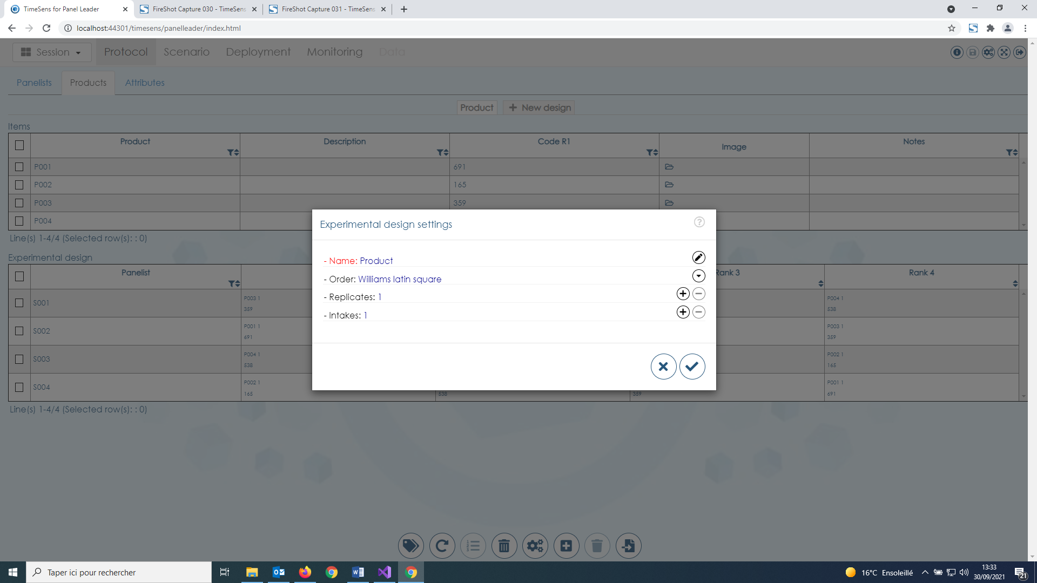

This screen allows property of the current design to be modified:

* **Name** have to be unique
* **Order** can be Fixed, Random or Williams Latin square
* **Replicates** is the number of times the sample will be replicated (presentation by block)
* **Intakes** is the number of intakes that will be presented (successive presentations)

### Remove selected products from current design

### Import products in current design or import an existing product design

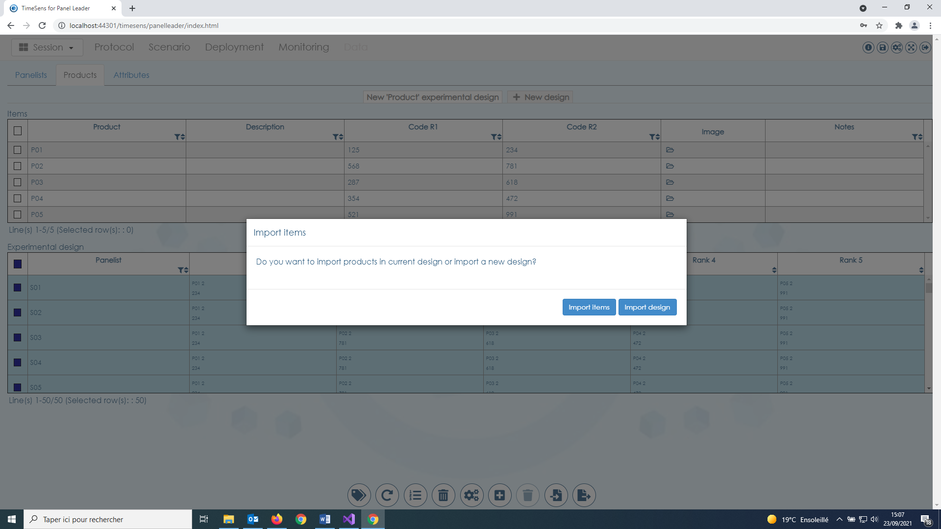

It is possible to import products (first table) or experimental designs (second table).

### Create a new product design

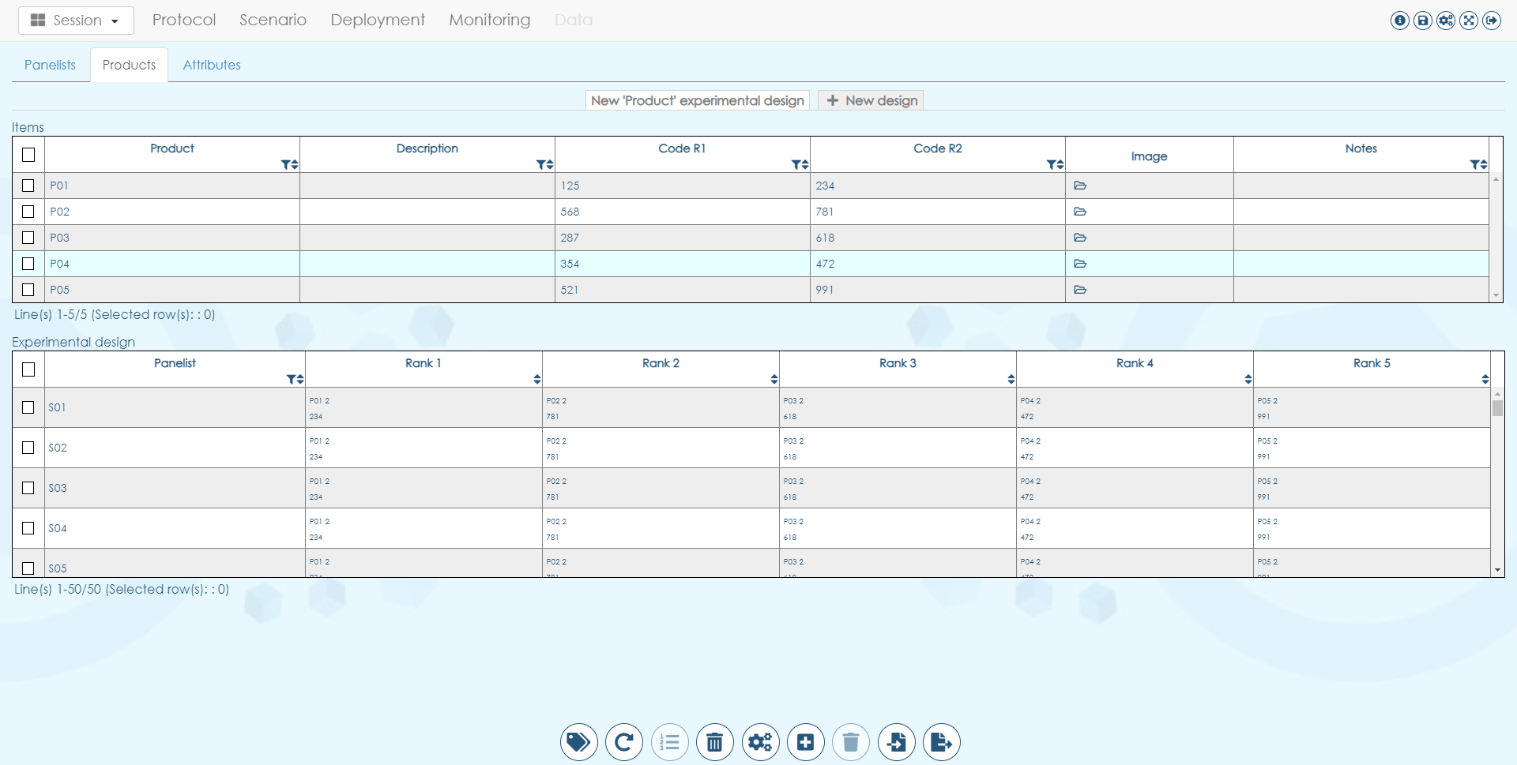

A session can contain multiple product experimental designs, for example to present successive sequence of different products.

## descriptors

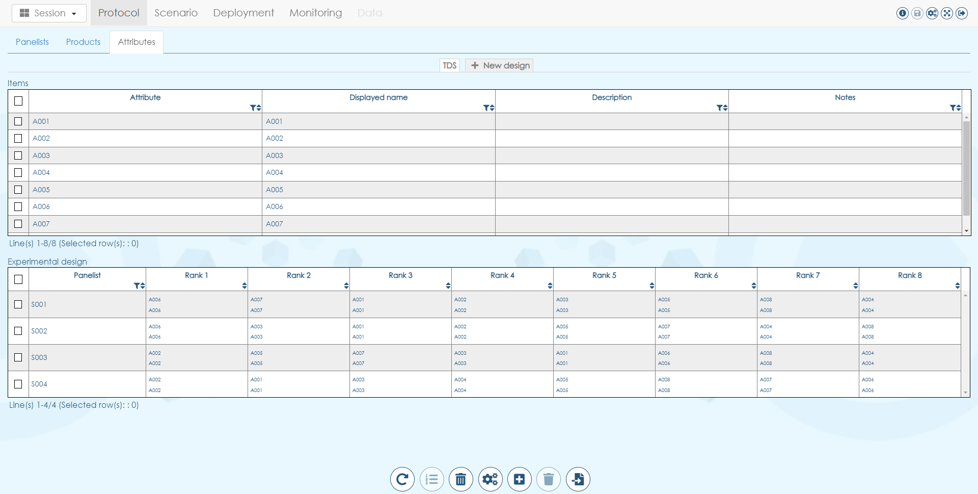

The first table gathers **information about the attributes**:

* **Attribute** is the code (unique, with no special character) that will be used to identify the attribute in the data (not displayed to panelists)
* **Displayed name** is the label that will be displayed to the panelists
* **Description** is the user-friendly description of the attribute (not displayed to panelists)
* **Notes** is an additional field to store information on the attribute

All features are the same as product design.

# Scenario tab

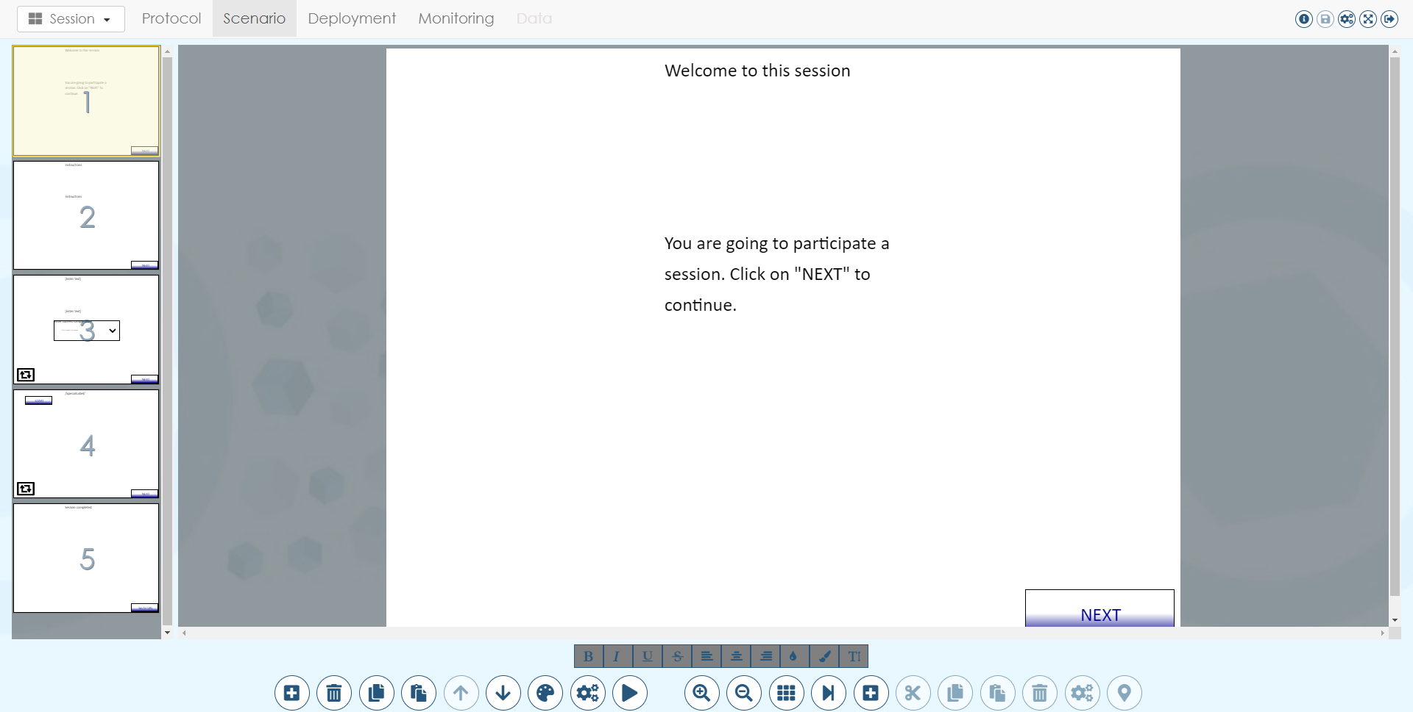

The screen list appears on the left as miniatures, the selected screen is highlighted in yellow in miniatures end is displayed on the right. All elements that appear on a screen are **controls t**hat can be customized.

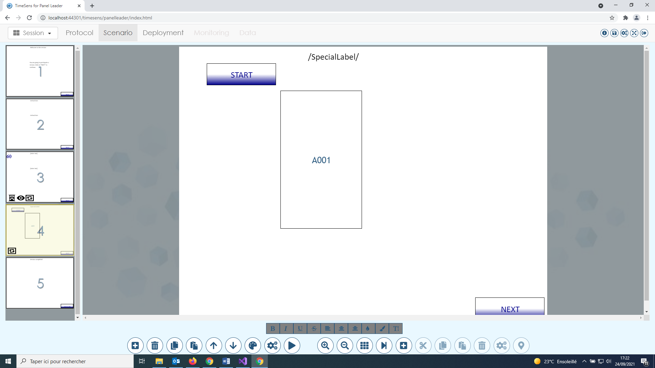

The icons displayed under the miniatures correspond, from left to right, to:

* **Timed screen**: screens having a timer (automatically goes to next screen after a given duration)
* **Conditional screen**: screens that are displayed only under certain conditions
* **Repeated screen\***:screens that are repeated according to an experimental design

**All consecutive repeated screens are replicated in a loop related to an experimental design**. In the example above, the screens will be presented in this order: 1, 2, **3, 4, 3, 4, 3, 4, …**, 5

## Edit screen LIST

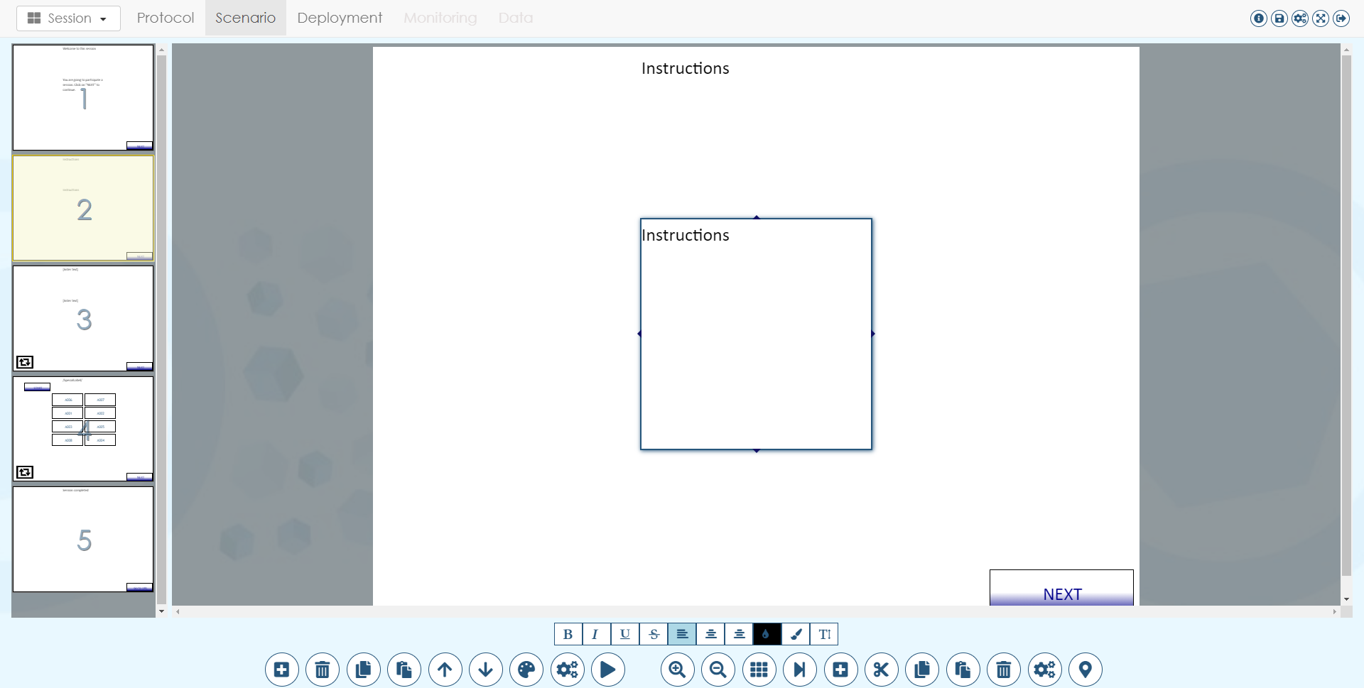

From left to right:

* **Insert a screen**
* **Remove selected screen**
* **Copy selected screen**
* **Paste copied screen**
* **Move up selected screen**
* **Move down selected screen**
* **Set screen style**
* **Edit screen properties**
* **Simulate scenario**

### Insert a screen

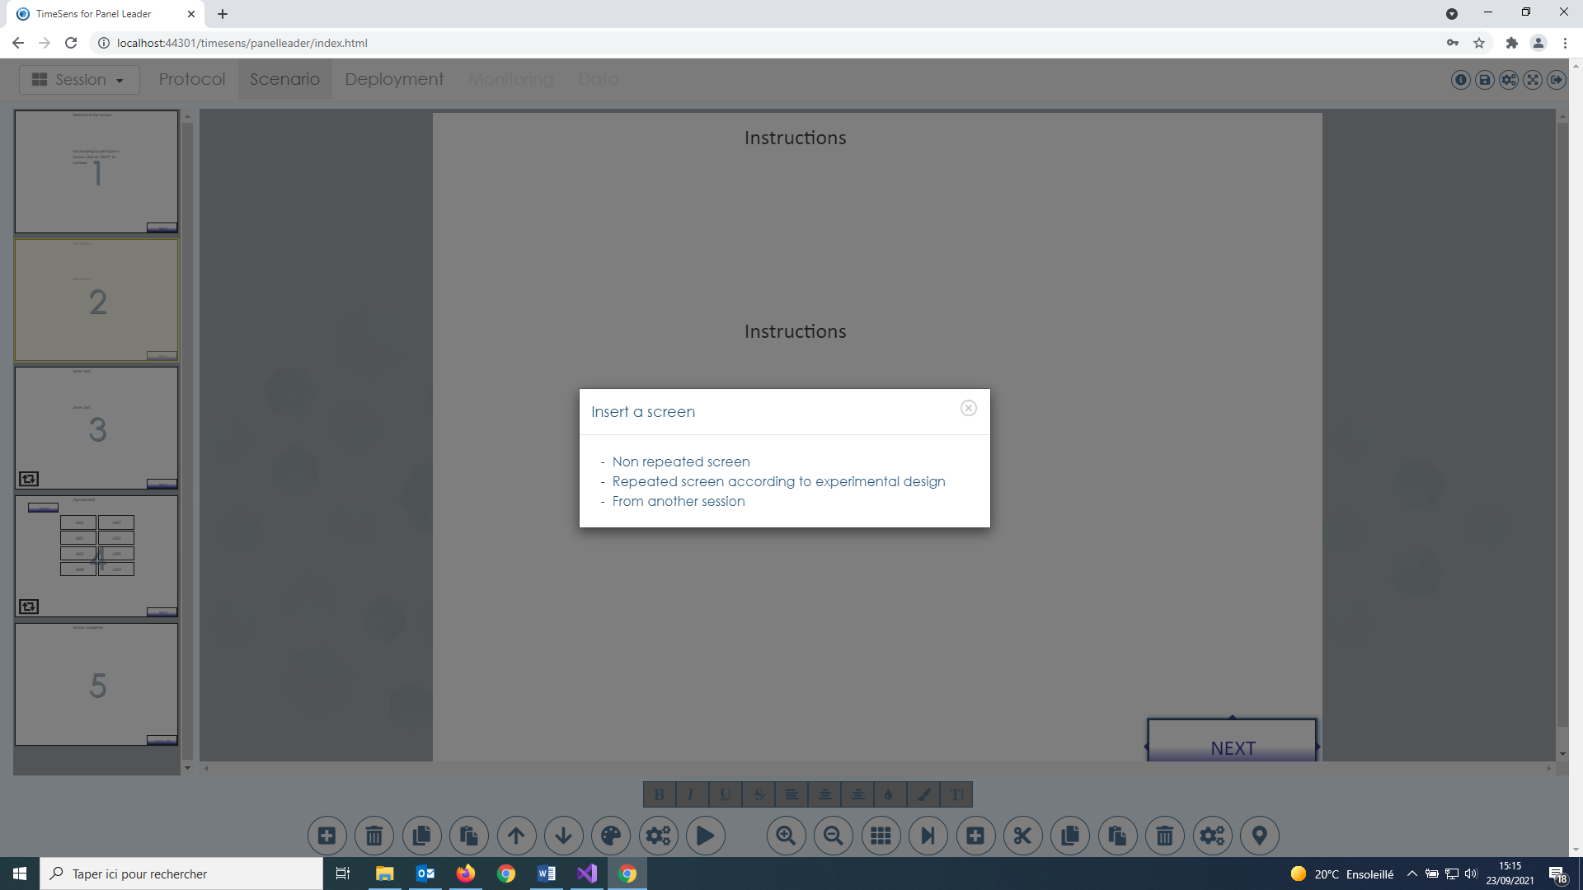

It allows to insert a new screen after the selected screen:

* **Non-repeated screen**: screen displayed once
* **Repeated screens**: screens repeated according to an experimental design (product or attribute)
* **From another session**: screen copied from another TimeSens session

### Set screen style

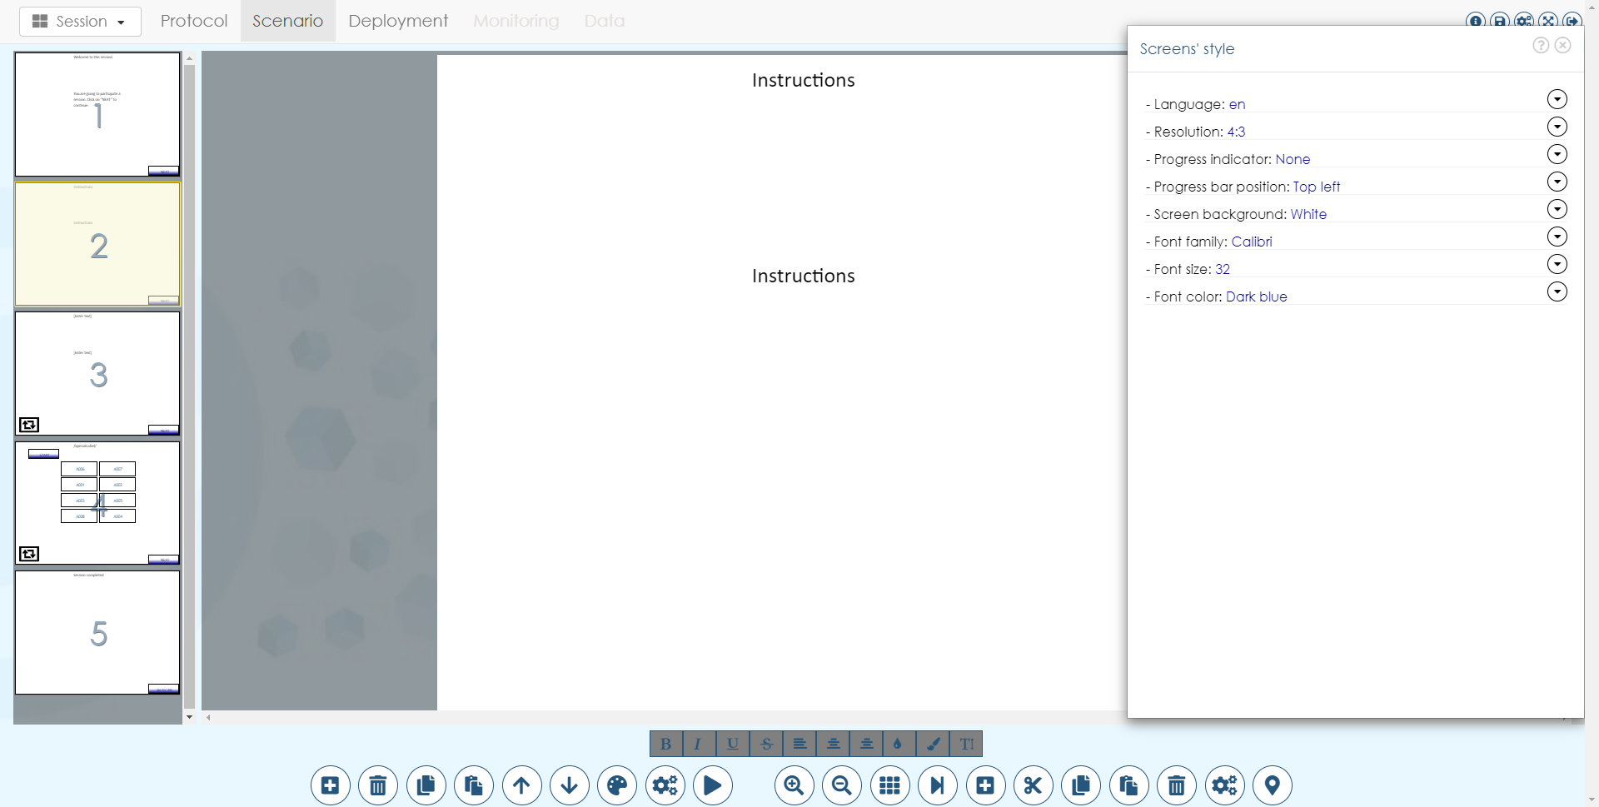

It allows to change the style for all the screens (see Create session > From wizard).

### Edit screen properties

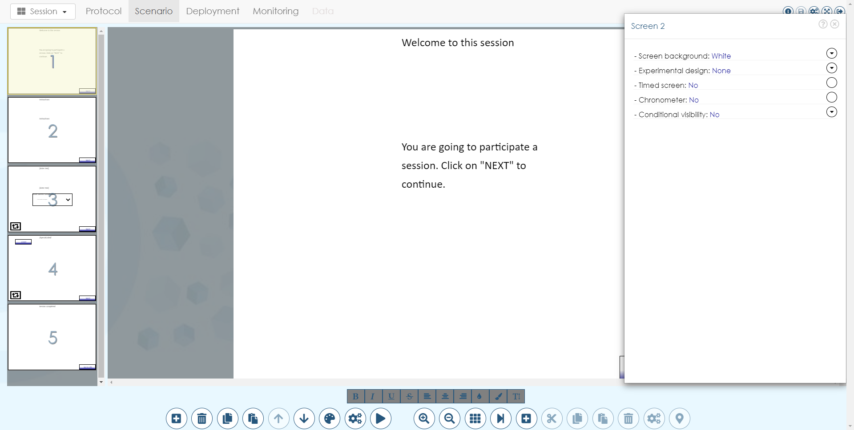

It allows to change the properties of the selected screen:

* **Screen background**: background color of the screen
* **Experimental design**: experimental design associated to the screen to be chosen in the list of experimental designs defined in the protocol tab (if none: non-repeated screen).
* **Timed screen**: if "yes", the screen will be displayed for "duration" seconds then the next screen will be displayed. Properties of the timer can be edited as any other control (see further).
* **Chronometer**: if "yes", a chronometer is added on the screen, it will disable all controls on the screen after "duration" seconds. Properties of the control can be edited as any other control (see further).
* **Conditional visibility**: by default, all screens are displayed. If any checkbox is display on the following screen, the screen will be displayed only when the checked conditions are filled (for example, a screen inviting the panelist to rinse his mouth can be displayed at ever product rank except the last one).

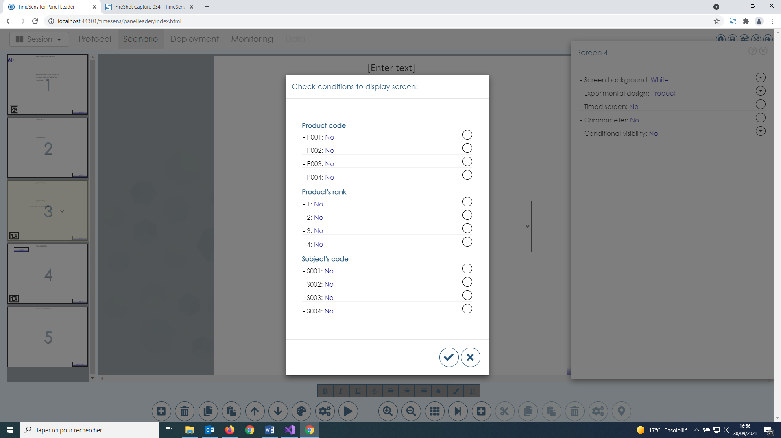

### Simulate scenario

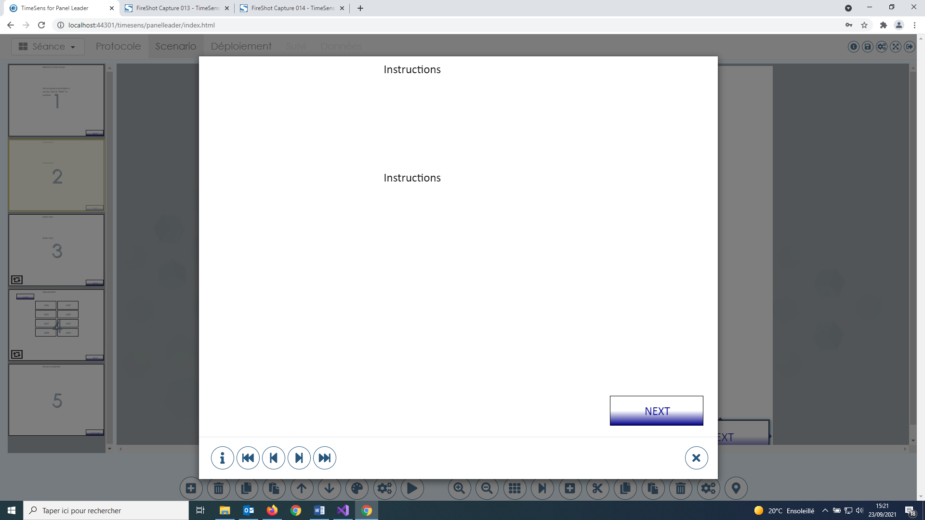

This screen allows to simulate the session, i.e. to see what the panelists will really see.

In simulation, screen constraints (timers, mandatory answered) can be bypassed using the following controls.



From left to right, the buttons allow to:

* **Get info on current screen**
* **Go to the first screen**
* **Go to the previous screen**
* **Go to the next screen**
* **Go to the last screen**

## Edit current screen



From left to right:

* **Zoom in**
* **Zoom out**
* **Toggle grid visibility**
* **Select next control**
* **Insert a control**
* **Cut selected control**
* **Copy selected control**
* **Paste copied control**
* **Remove selected control**
* **Edit selected control properties**
* **Align selected control**

### Toggle grid visibility

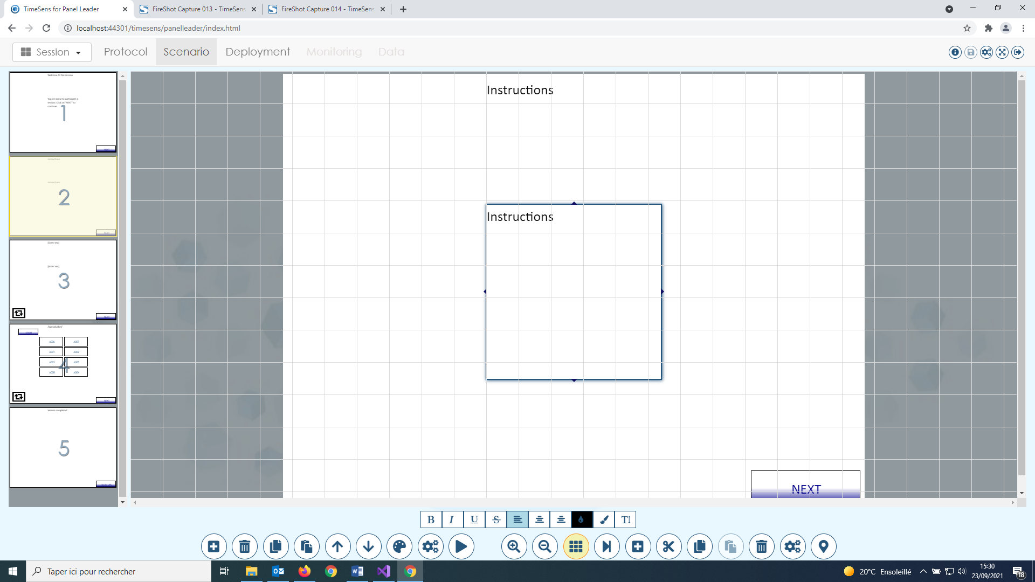

This option allows to see a grid in order to align the controls. The button can be clicked several times to increase grid precision or to remove the grid. The grid will not be displayed to the panelists.

### Align selected control

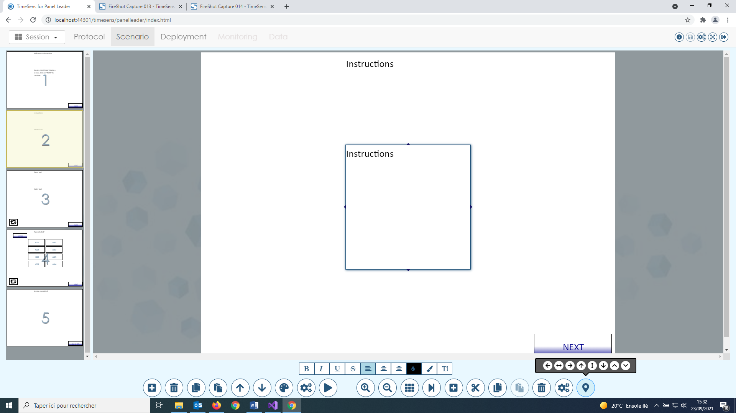

From left to right, these buttons allow to align the select control on the screen: horizontal left, horizontal center, horizontal right, vertical top, vertical center, vertical bottom, move forward, move backward.

### Insert a control

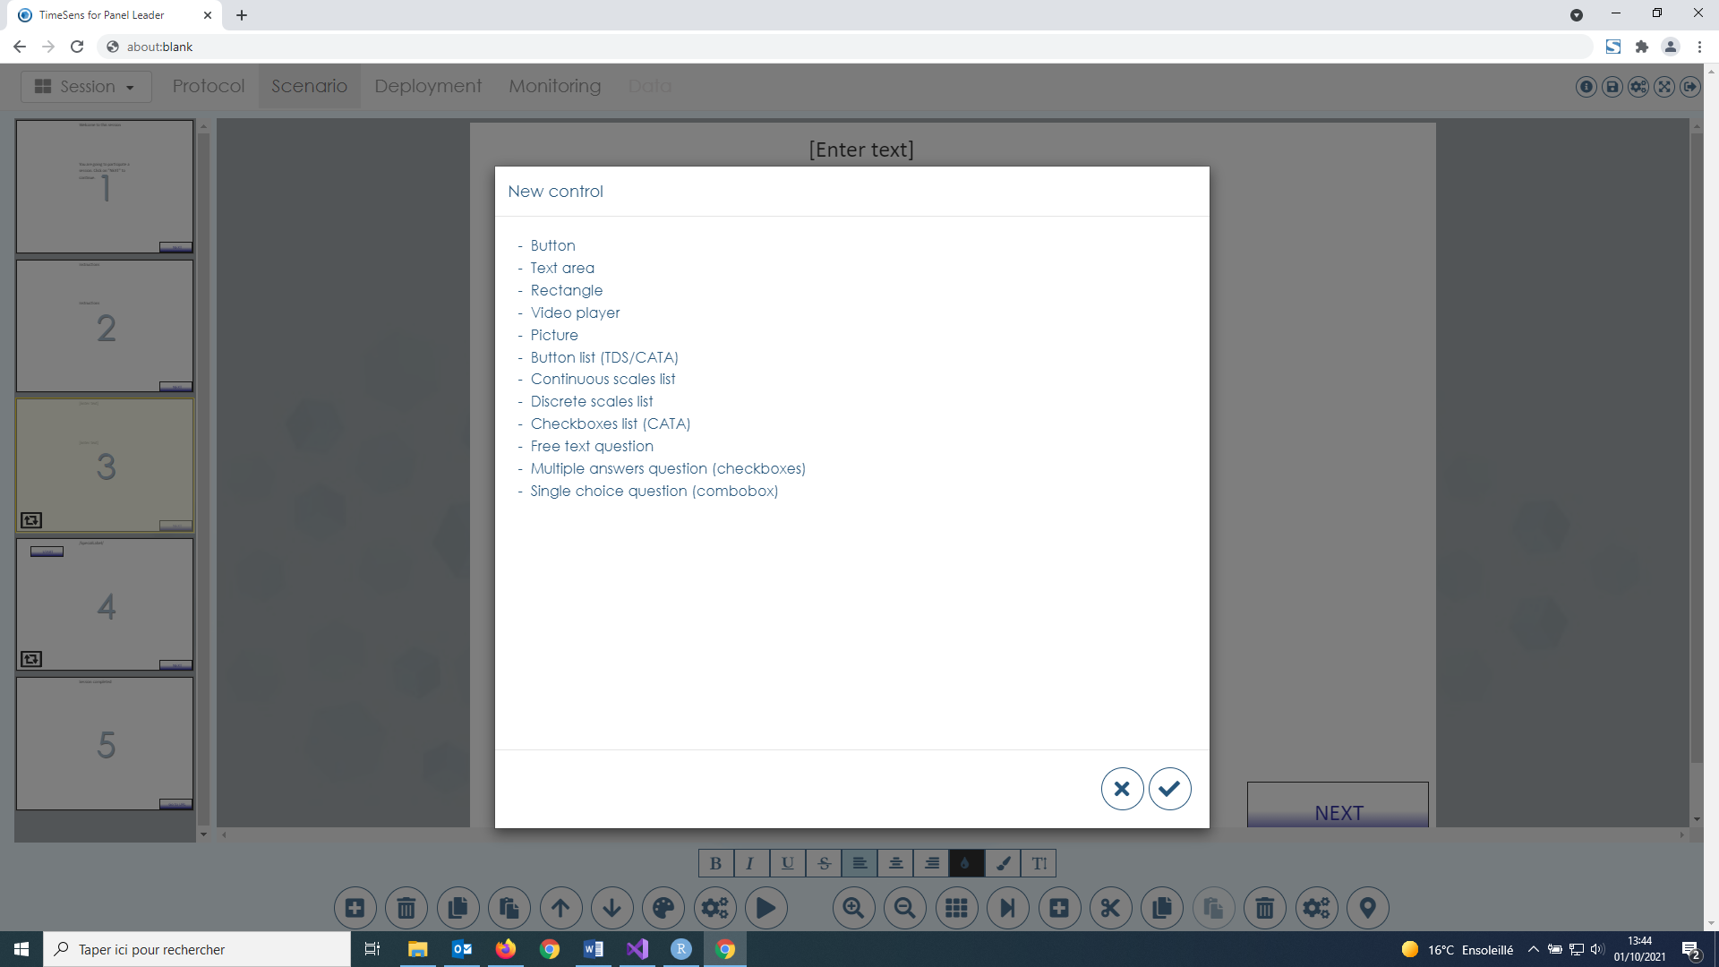

This screen allows to insert a new control on the selected screen. Depending on the control, a screen will ask for control properties to be defined. The properties of the control can also be edited using the button "Edit selected control properties" (see below).

### Edit selected control properties

#### Properties common to all controls

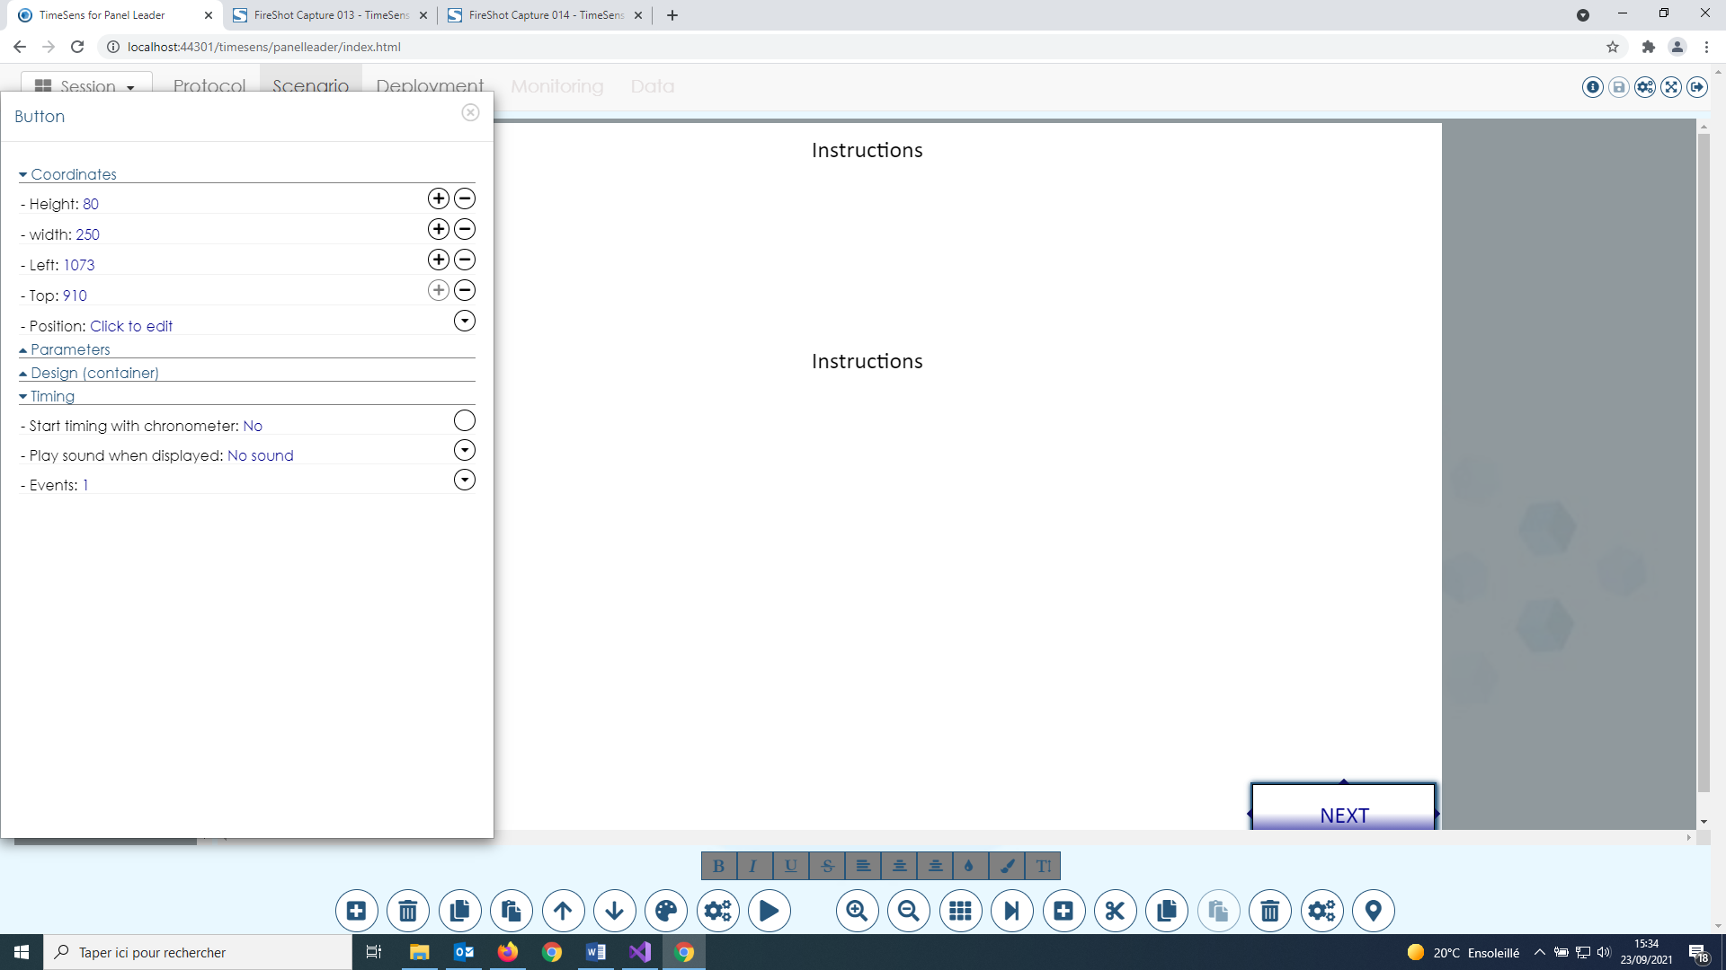

This screen allows to change the properties related to the coordinates of the selected control:

* **Height**: enter a number or click on the plus/minus symbol to change the height of the selected control.
* **Width**: enter a number or click on the plus/minus symbol to change the width of the selected control.
* **Left**: enter a number or click on the plus/minus symbol to change the left coordinate of the selected control.
* **Top**: enter a number or click on the plus/minus symbol to change the top coordinate of the selected control.
* **Position**: click on the button to change the relative position of the selected control.

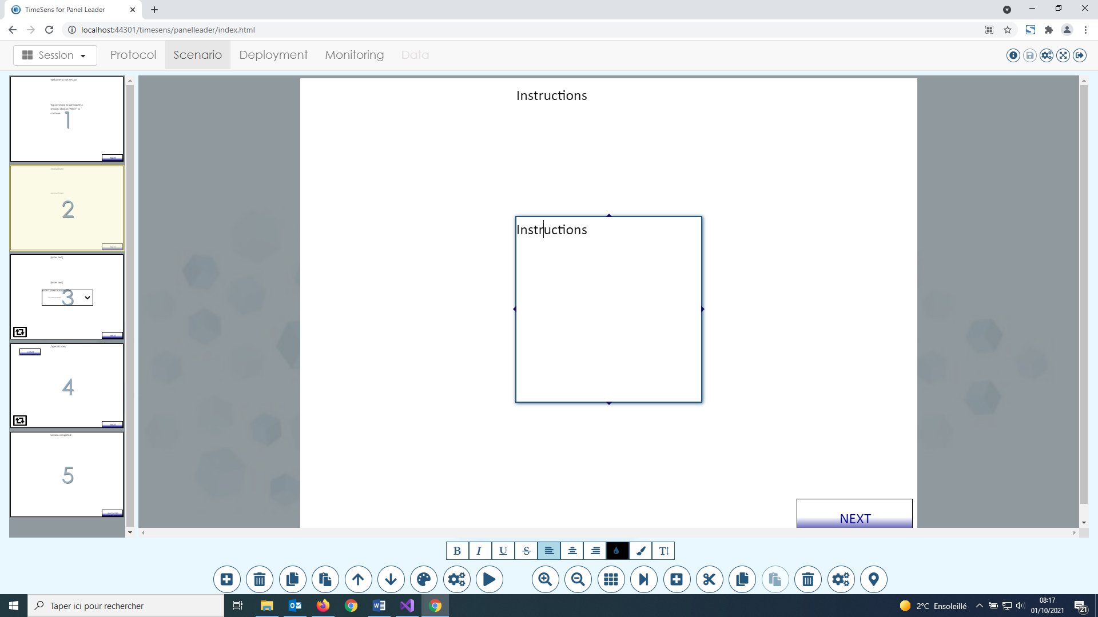

The coordinates can also be changed using the top, bottom, left and right handles, or by drag and move the border of the selected control.



This screen allows to change the properties related to the timing of the selected control:

* **Start timing with chronometer**: click on the button to toggle between "Yes" and "No" (default). If no, timing starts when the screen is displayed, if yes, when the chronometer starts.
* **Play sound when displayed**: click on the button to select an option between "No sound" (default), "Default sound" or "Custom sound" (.WAV file). When one of the last 2 options is chosen, a sound is played when the control change of state from "hidden" to "visible" (see below).
* **Events**: click on the button to define the timing of the control.

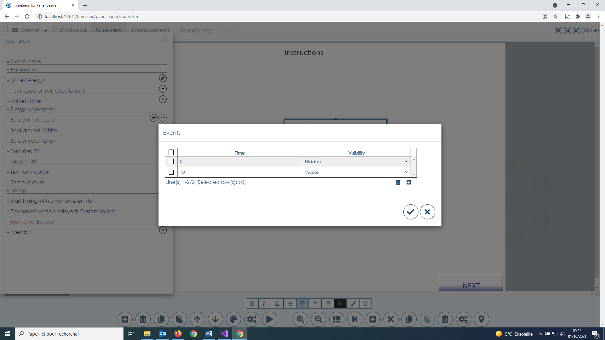

Events correspond to specific time points when control visibility changes. By default, all controls are visible when the screen is displayed (time=0, visibility=visible). In the example above, when the screen will display, the control will be hidden, and it will be visible after 10 seconds. The icons at the bottom of the table allow to remove and add events.

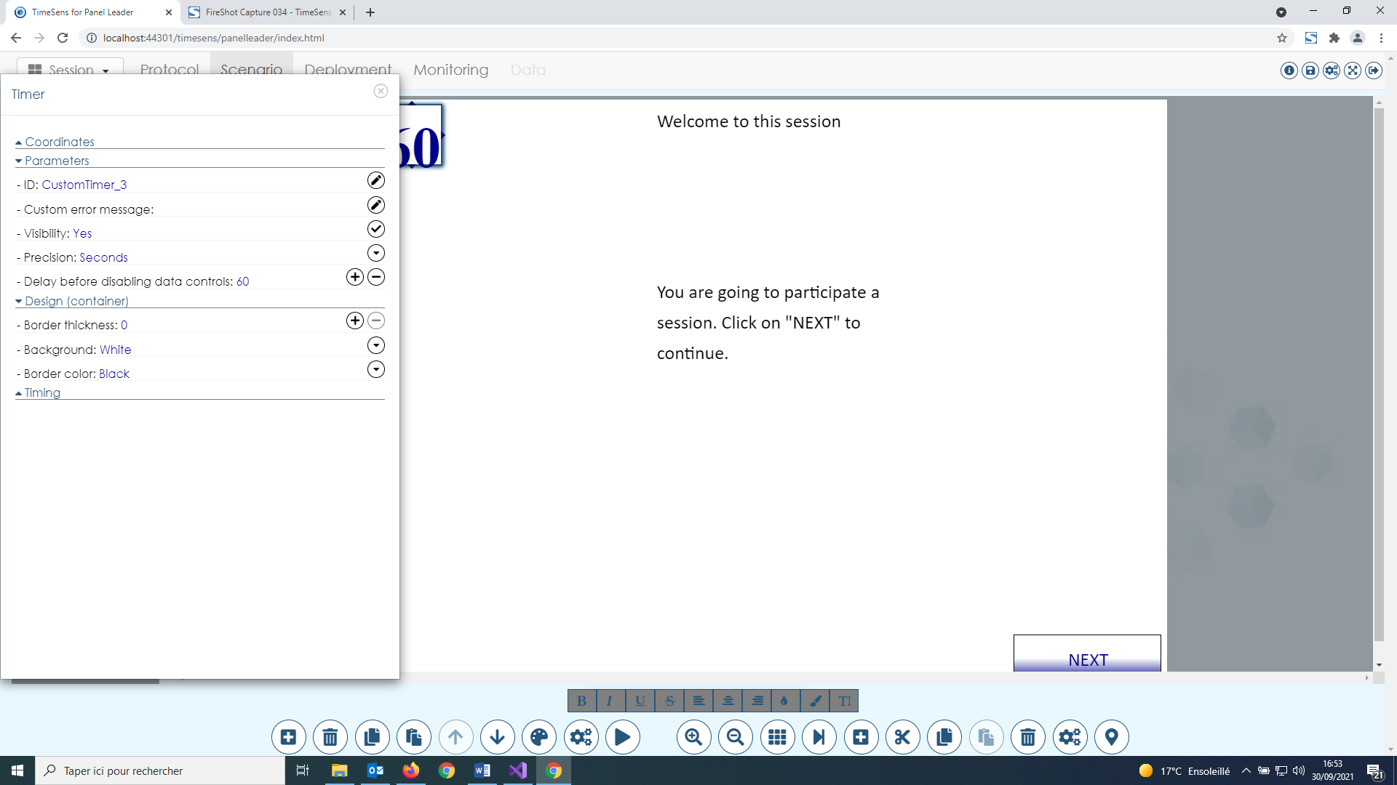

This screen allows to change the design of the selected control:

* **Border thickness**: enter a number or click on the plus/minus symbol to change the thickness of the border of the container of the control.
* **Background**: click on the button and select a color to change the background color of the container of the control.
* **Border color**: click on the button and select a color to change the color of the border of the container of the control.

#### Timer/Chronometer properties



As there can be only one timer and/or one chronometer on a screen, these controls can only be inserted from the screen properties (see above). This screen box allows to change the properties related to timer/chronometer controls:

* **Visibility**: click on the button to toggle between "Yes" and "No" (default).
* **Precision**: click on the button to select an option between "Minutes" and "Seconds"
* **Delay/max time before disabling data controls**: max time before to go to the next screen (timer) or to disable the controls on the screen except "next" button (chronometer).

#### Button properties

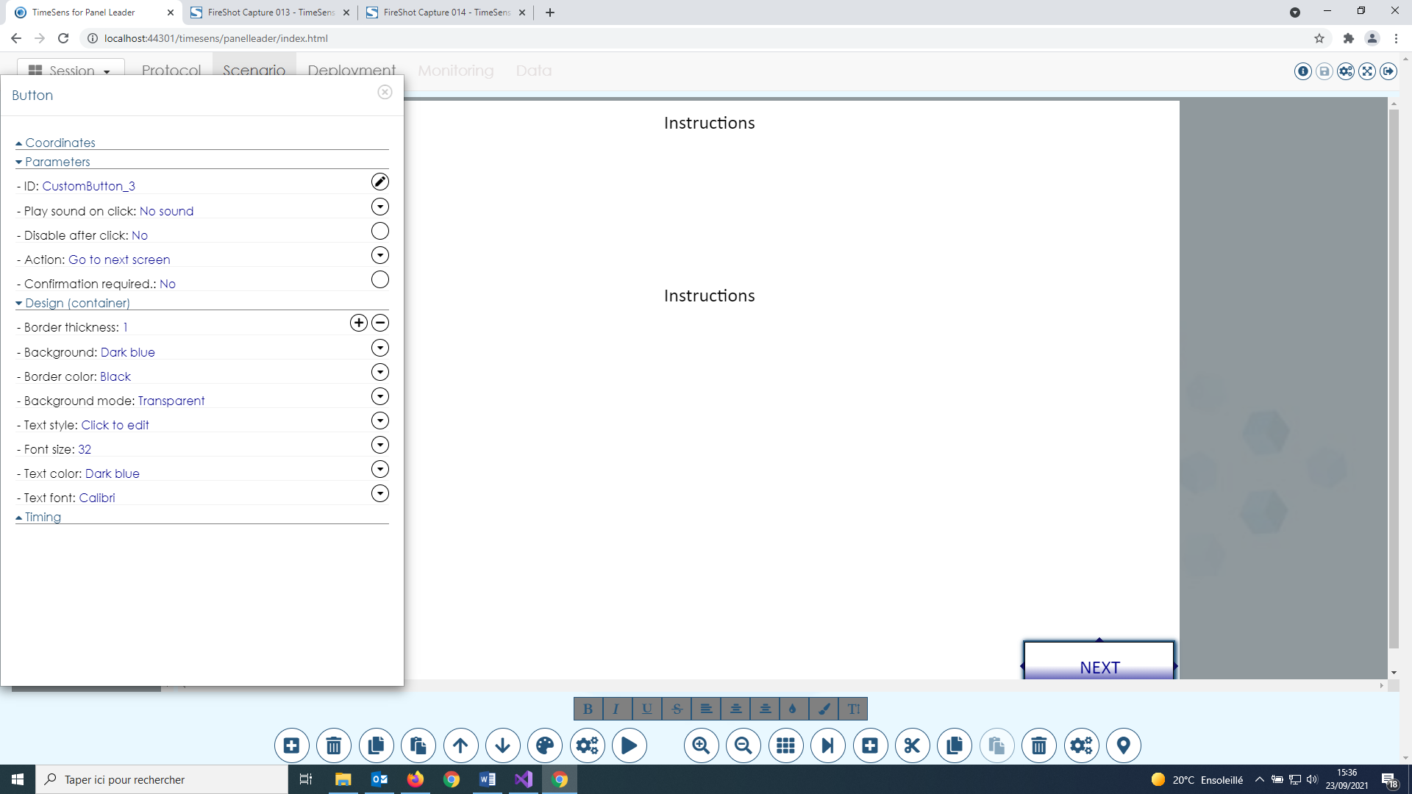

This screen allows to change the properties related to button controls:

* **Play sound on click**: click on the button to select an option between "No sound" (default), "Default sound" or "Custom sound" (.WAV file). When one of the last 2 options is chosen, a sound is played when the panelist clicks on the button.
* **Disable after click**: click on the button to toggle between "Yes" and "No" (default). If "No", the button will be disabled after being clicked.
* **Action**: click on the button to select an option between
  + Go to previous screen
  + Go to next screen
  + Go to login screen
  + Go to specific screen
  + Go to URL
  + Go to URL and go to next screen
  + Temporal Dominance of Sensations
  + Save an event
  + Save an event then go to next screen
  + Start the same session with a new panelist
  + Hide group of control
  + Show group of control
  + Start chronometer
  + Stop chronometer
  + Stop chronometer then go to next screen
  + Go to specific screen (conditional)
* **Confirmation required**: click on the button to toggle between "Yes" and "No" (default). If "No", a confirmation will be required before the selected action occurs.
* **Background mode:** click on the button to select an option between "Transparent", "Opaque" or "Image"
* **Text style:** click on the button to select an option between "Normal", "Bold", "Italic" or "Bold and italic"
* **Font size:** click on the button to select the size of the text of the button
* **Text color:** click on the button to select the color of the text of the button
* **Text font:** click on the button to select the font of the text of the button

The text of the button can be edited directly.

#### Textarea properties

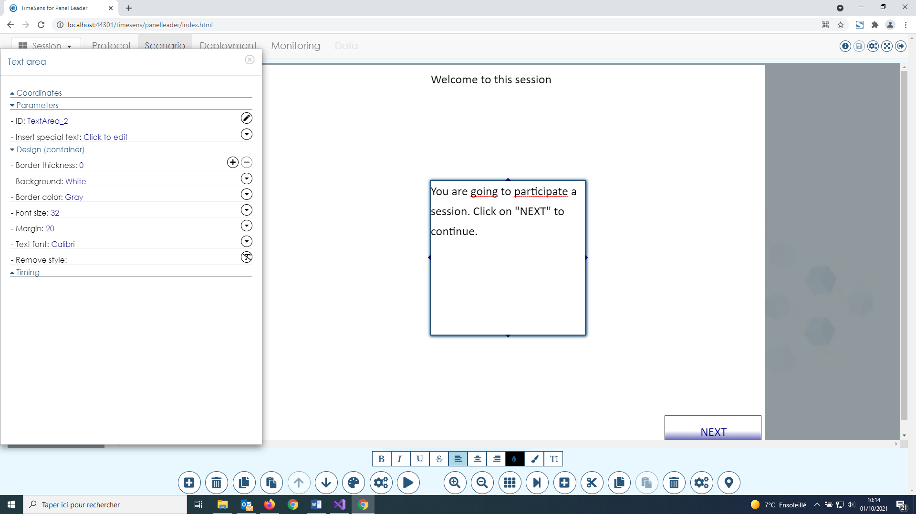

This screen allows to change the properties related to textarea controls:

* **Play sound on click**: click on the button to select an option between "No sound" (default), "Default sound" or "Custom sound" (.WAV file). When one of the last 2 options is chosen, a sound is played when the panelist clicks on the button.
* **Insert special text**: click on the button to select a special text to be inserted at the current cursor position, between
  + Current date
  + Subject's code: the code of the subject
  + Replicate: the current replicate of the displayed sample, depending on the experimental design
  + Intake: the current intake of the displayed sample, depending on the experimental design
  + Product's rank: the rank of the displayed sample, depending on the experimental design
  + Product description: the content of the field "Description" of the product as defined in protocol
  + Panelist's note: the content of the field "Notes" of the panelist as defined in protocol
  + Current experimental design's item label: the code of the displayed sample, depending on the experimental design

The text of the textarea can be edited directly. **Additional design options are available for the selected text**:



From left to right: Bold, Italic, Underline, Strikethrough, Left align, Center align, Right align, Text color, Underline, **Text size (text size is relative to the paragraph size)**.

#### Video player properties

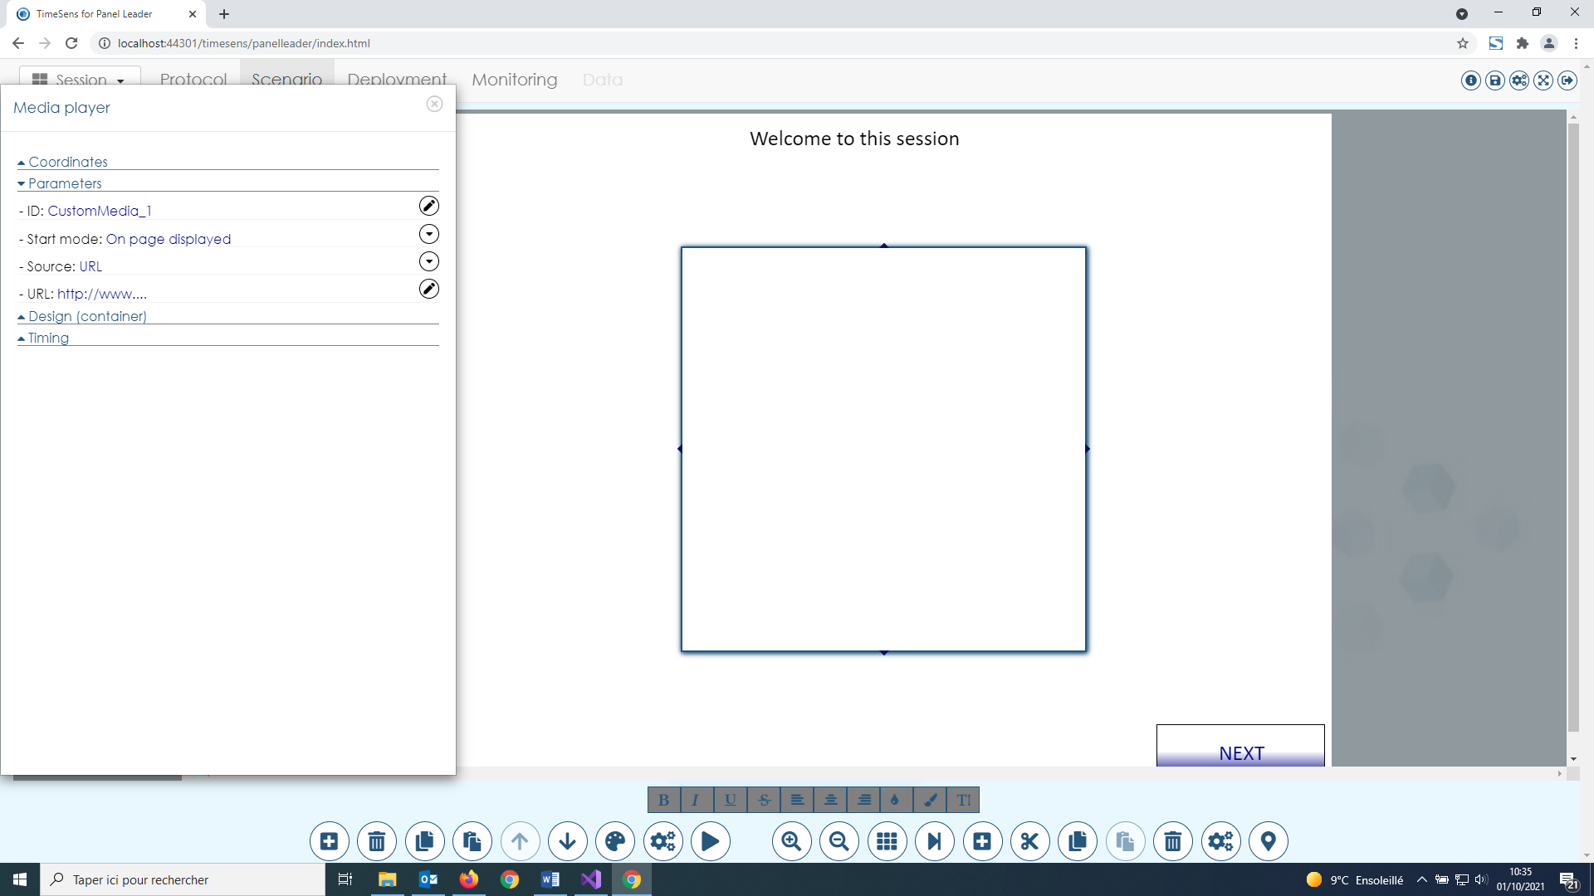

This screen allows to change the properties related to video player controls:

* **Start mode**: click on the button to select when the video the player starts to read the video between
  + On page displayed: when the page is displayed
  + Click on 'Start' button: when the panelist clicks on a button with action “start”
  + Click on player: when the panelist clicks anywhere on the player
* **Source:** click on the button to select the source of the video between
  + None
  + Local disk: a video file (.MP4) on the disk. This option could make the session slower to download by the panelists.
  + URL: a video file (.MP4) on the internet
  + YouTube video: a YouTube video.
* **URL**: depending on source, an URL of a video file or YouTube file.

#### Picture properties

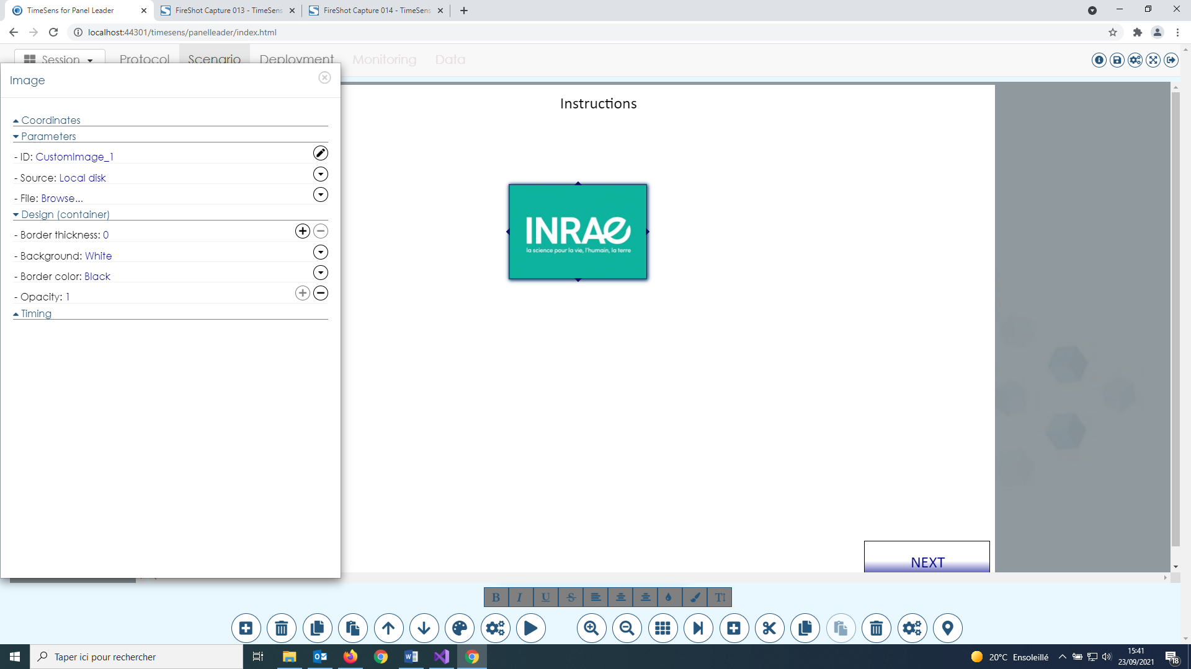

This screen allows to change the properties related to picture controls:

* **Source:** click on the button to select the source of the picture between
  + None
  + Local disk: a picture file (.PNG or .JPG) on the disk. This option could make the session slower to download by the panelists.
  + URL: a picture file (.PNG or .JPG) on the internet
* **URL**: depending on source, an URL of a picture file.
* **Opacity**: enter a number between 0 (transparent) and 1 (opaque) or click on the plus/minus symbol to change the opacity of the picture.

#### Data control properties

Data controls include "button list", "continuous scale", "discrete scale", "checkboxes" and questions. **These controls allow data to be recorded depending on sensory protocols. The sensory protocol is determined by the type of control and the data type asked at the moment the control is inserted (example with buttons list, see below):**

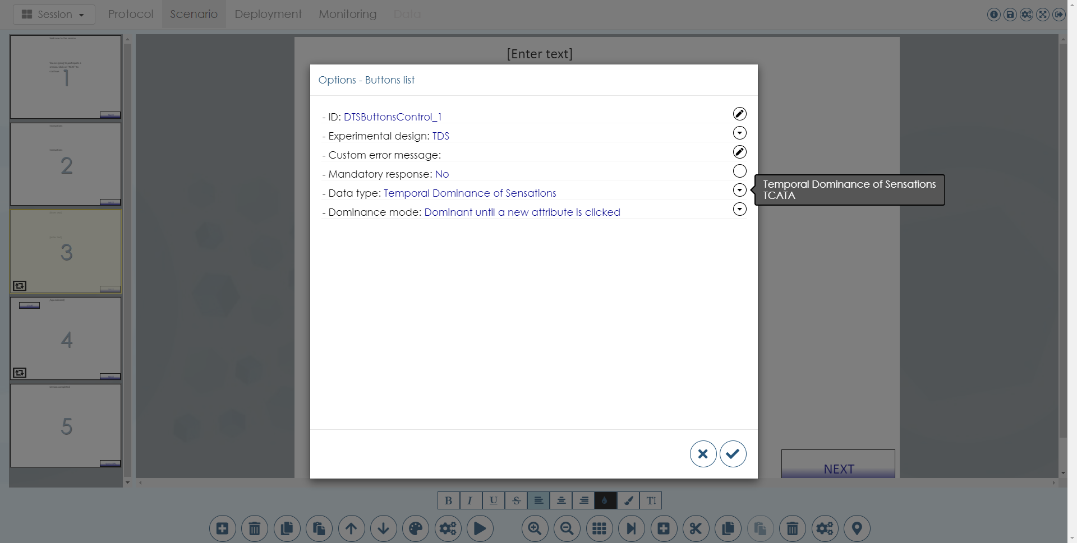

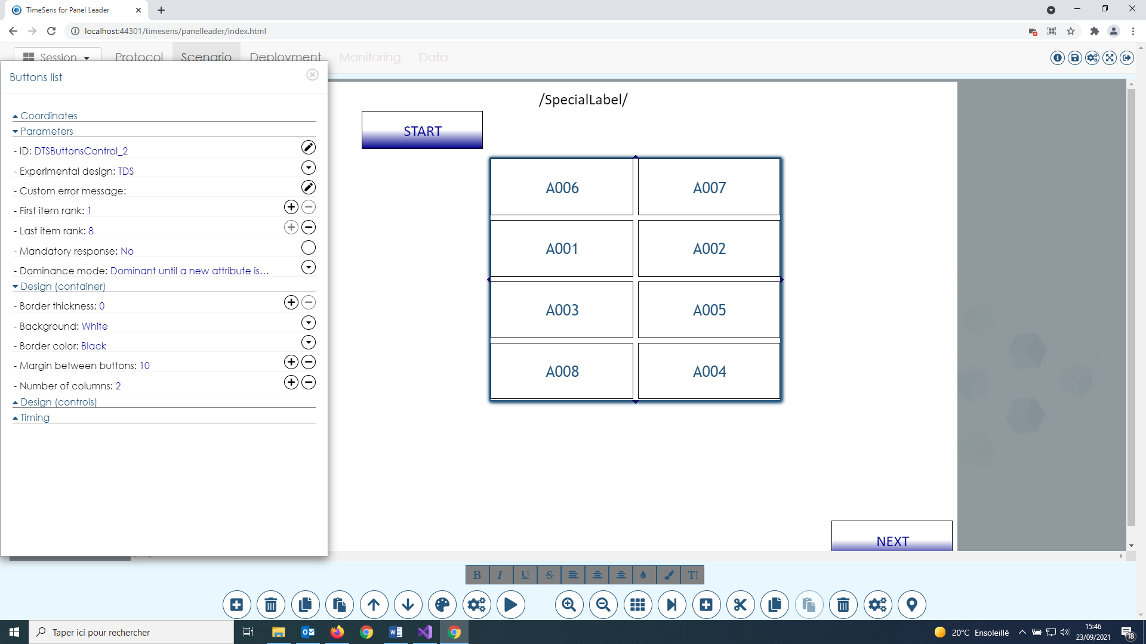

**Some properties are common to most data controls**:

* **ID**: fill in the textbox to change the **unique identifier** of the control. This ID will be used to retrieve the control that allows data collection (for example, if there are multiples TDS in a same session).
* **Experimental design:** click on the button to select the descriptor experimental design.
* **Custom error message**: fill in the textbox to change the error message displayed if the control in is an error state (for example, a profile control with unscored descriptors).
* **First and last item rank**: enter a number between 1 and n (number of descriptors in the experimental design) or click on the plus/minus symbol to change the ranks of the first and last attributes to be displayed on the screen. For example, to split a profile with 20 descriptors on 2 successive screens, on the first screen first item rank will be 1 and last item rank 10, on the second screen 11 and 20.

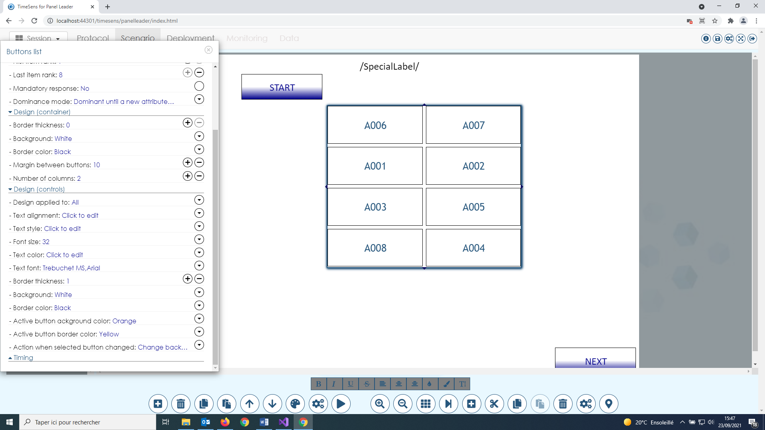

**Some design properties are common to most data controls**:

* **Design applied to**: click on the button to select an option between "All" (default) or the code of a descriptor present in the control experimental design. All following design changes are applied to the "All/Specific descriptor «scales/buttons inside the control.
* **Text alignment**
* **Text style**
* **Font size**
* **Text color**
* **Text font**
* **Border thickness**
* **Background**
* **Border color**

#### Button list/ Checkboxes properties





This screen allows to change the properties related to **button list (TDS/TCATA)** controls:

* **Mandatory response**: click on the button to toggle between "Yes" and "No" (default). If "Yes", at least one descriptor has to be clicked to enable the panelist to go to the next page. **This option is not compatible with timers/chronometers.**
* **Dominance mode:** click on the button to select an option between
  + Dominant until a new attribute is clicked
  + Dominant until a new attribute is clicked or this attribute is unclicked
  + Dominant while button is held down
  + Dominant for a limited duration
* **Number of columns**: enter a number or click on the plus/minus symbol to change the number of columns.
* **Margin between buttons**: enter a number or click on the plus/minus symbol to change the space between the buttons
* **Active button background color**: click on the button to select the color of the selected button(s)
* **Active button border color**: click on the button to select the color of the border(s) of the selected button(s)
* **Action when selected button changed**: click on the button to select an option
  + Change background
  + Change border
  + Change background and border
  + Change nothing

#### Continuous scale properties

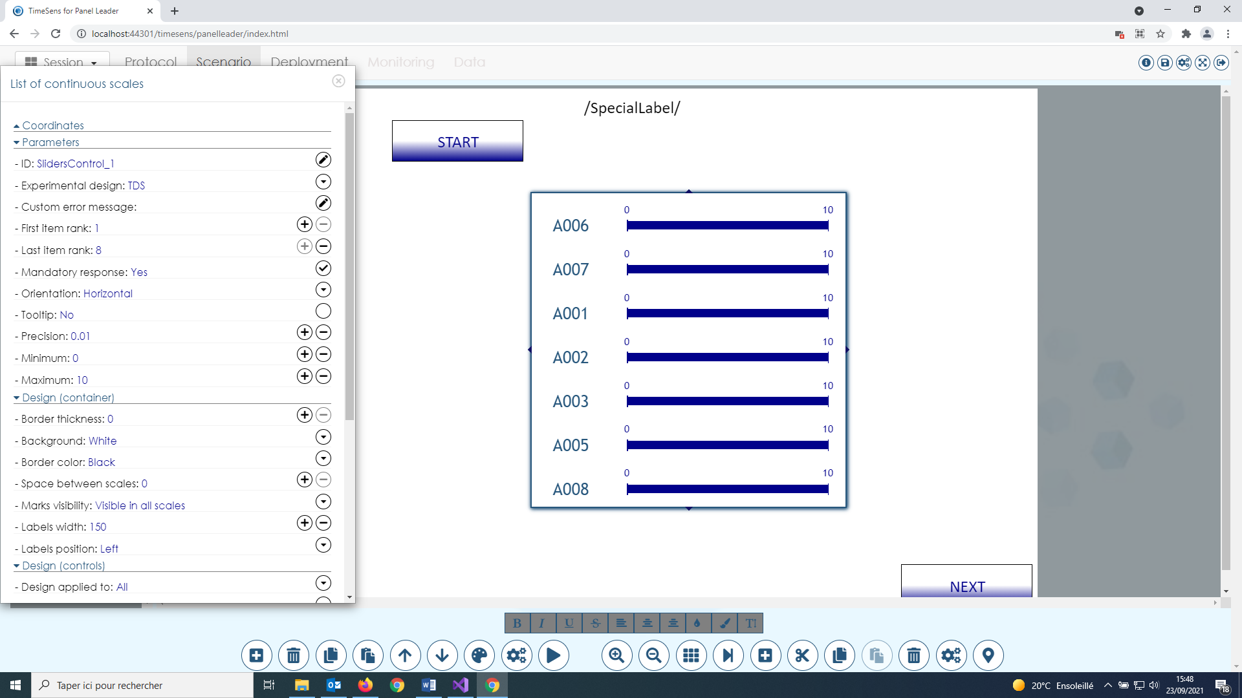

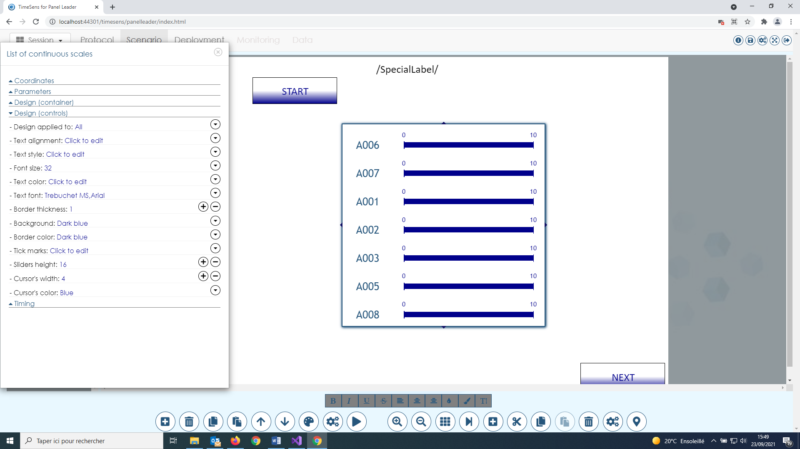

This screen allows to change the properties related to **continuous scales (Hedonic test/Dynamic liking/Progressive liking/Profile/Dynamic profile/Progressive profile)** controls:

* **Orientation**: click on the button to select an option between "Horizontal" and "Vertical"
* **Tooltip**: click on the button to toggle between "Yes" and "No". If "Yes", a help icon will be displayed next to the label of the attribute.
* **Precision**: enter a number or click on the plus/minus symbol to change the precision of the continuous scale.
* **Minimum**: enter a number or click on the plus/minus symbol to change the left value of the continuous scale.
* **Maximum**: enter a number or click on the plus/minus symbol to change the right value of the continuous scale.
* **Space between scales**: enter a number or click on the plus/minus symbol to change the space between the scales
* **Marks visibility**: click on the button to select an option for the tick mark visibility, between
  + Never visible
  + Visible in all scales
  + Visible on first scale
  + Visible on last scale
* **Label width**: enter a number or click on the plus/minus symbol to change the width granted to the labels of the attributes
* **Label position**: click on the button to select an option for the position of the label compared to the scale
  + – (no label displayed)
  + Left
  + Right
  + Top center
  + Top left
  + Top right
  + Bottom center
  + Bottom left
  + Bottom right
* **Tick marks**: click on the button to define the tick marks (see below)
* **Sliders height**: enter a number or click on the plus/minus symbol to change the height of the scale
* **Cursor width**: enter a number or click on the plus/minus symbol to change the width of the cursor
* **Cursor color**: click on the button to select the color of the cursor

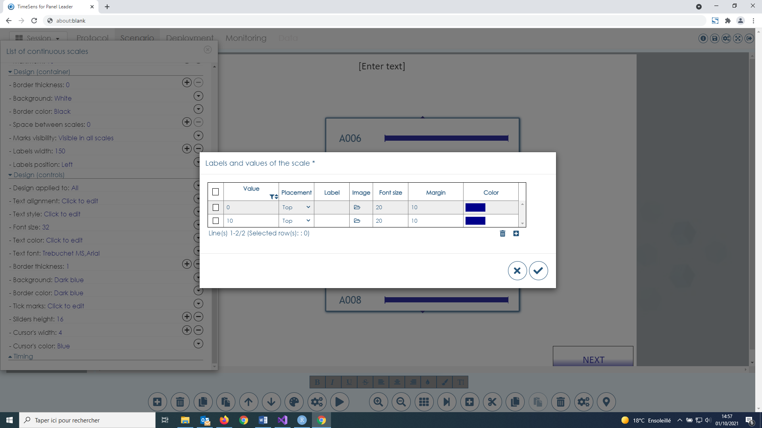

The buttons at the bottom right of the table allow to add/remove tick mark.

**Tick marks have the following properties than can be changed for all scales or specific ones if "Design applied to" is different from "All":**

* **Value**: enter a number in the boundaries of the scale to add a tick mark at this position
* **Placement**: click on dropdown icon to select the placement of the label of the tick mark
* **Label**: enter a label for the tick mark
* **Image**: browse for an image file to replace the label by a picture (experimental)
* **Font size**: enter a number corresponding to the size of the text of the label
* **Margin**: enter a number corresponding to the margin between the label and the scale
* **Color**: select a color for the label

#### Discrete scale properties

This screen allows to change the properties related to **discrete scales (Hedonic test/Dynamic liking/Progressive liking/Profile/Dynamic profile/Progressive profile)** controls. The property are the same as continuous scales, except:

* **Can uncheck**: click on the button to toggle between "Yes" and "No" (default). If "Yes", the checkboxes can be unchecked.

#### Free text question properties

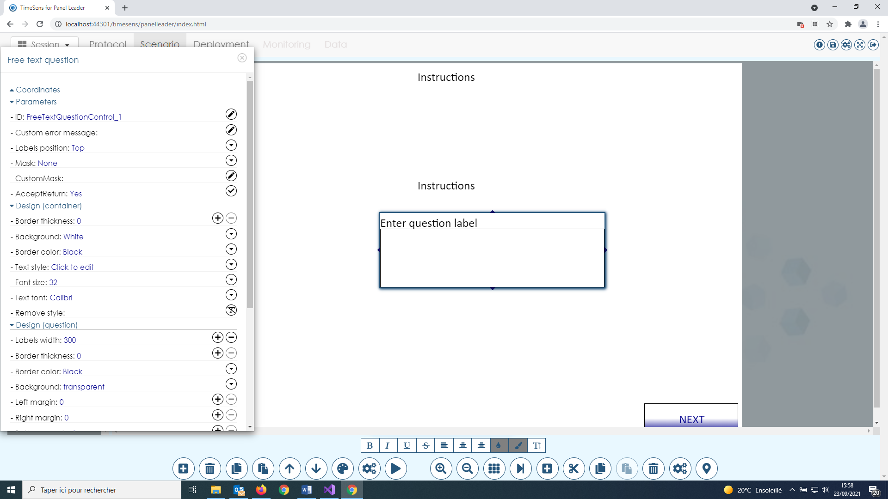

This screen allows to change the properties related to free text questions:

* **Label position**: click on the button to select the relative position of the label of the question compared to the textbox.
* **Mask**: click to select a predefine mask for the answer
* **Custom mask**: enter a regular expression to define a custom mask for the answer. Regular expression are patterns used by string-searching algorithms, numerous examples can be found on internet.
* **Accept return**: click on the button to toggle between "Yes" (default) and "No". If "No", the panelists can’t enter carriage return in the textbox.

#### Multiple answers question properties

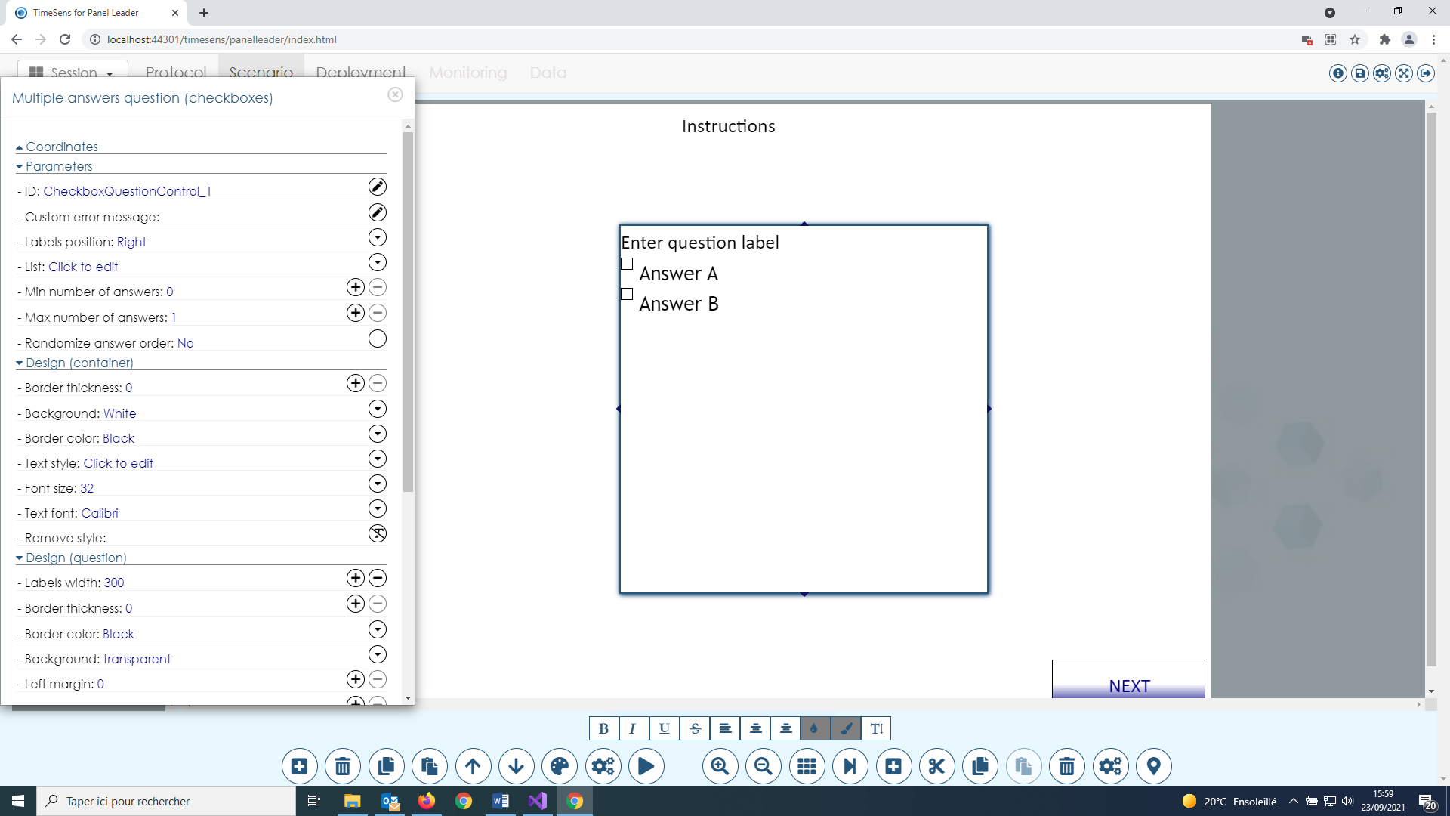

This screen allows to change the properties related to multiple answers questions:

* **List**: click on the button to edit the values of the answers (see below).
* **Min/max number of answers**: enter a number or click on the plus/minus symbol to change the values.
* **Randomize answer**: click on the button to toggle between "Yes" and "No" (default).

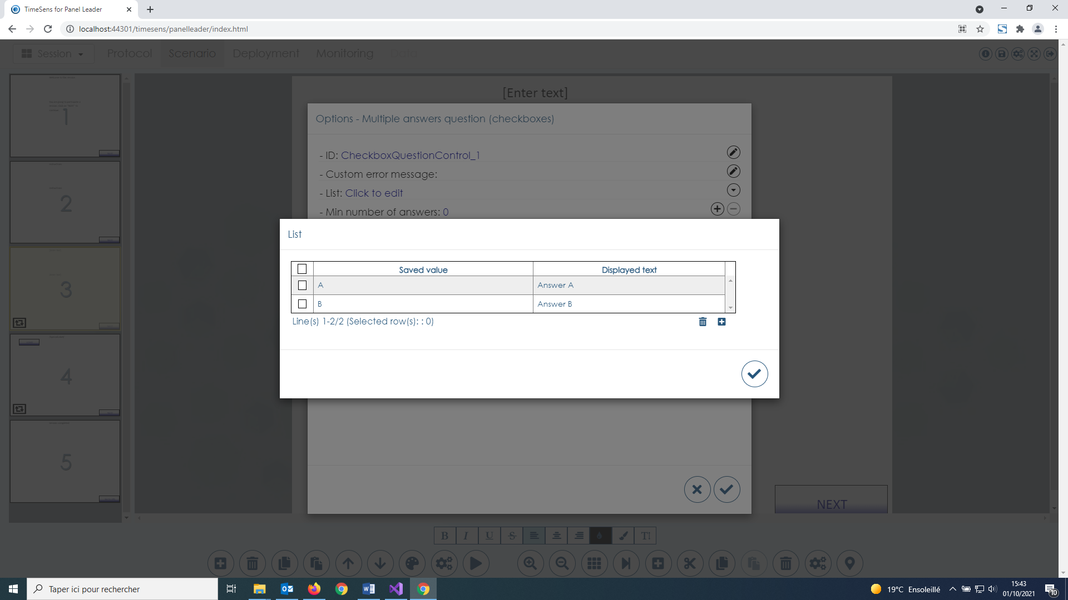

The buttons at the bottom right of the table allow to add/remove answers. The first column corresponds to the value that will be saved in the data, the second column is the displayed text.

#### Single answer question properties

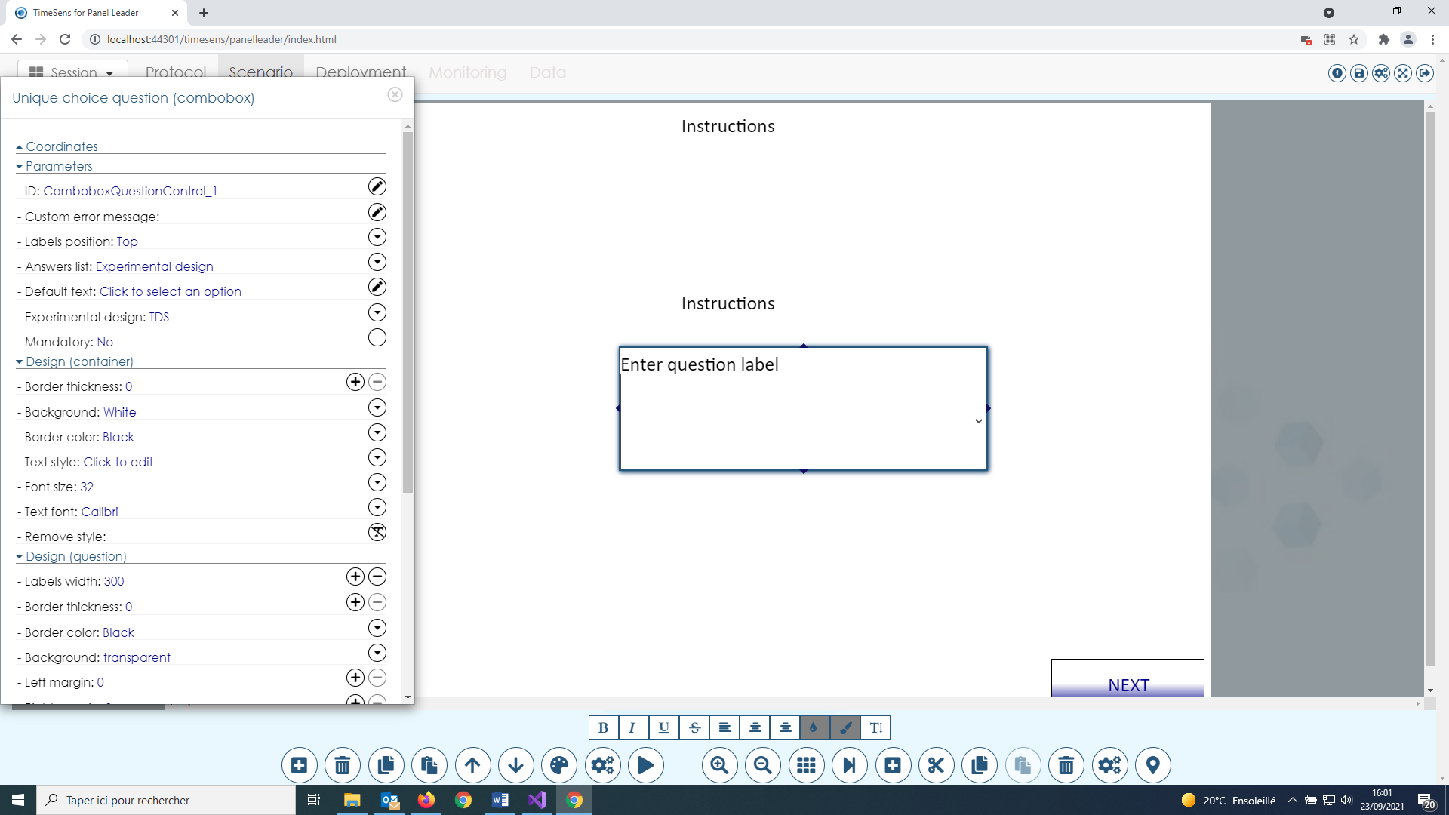

This screen allows to change the properties related to single answer questions:

* **Answers list**: click on the button to select the source of the values of the answers: experimental design or list (as with multiple answers questions)
* **Default text**: enter a text to replace the default text displayed in the dropdown list when there is no selected value.
* **Experimental design**: click on the button to select the experimental design (if "Answers list=experimental design")
* **Mandatory**: click on the button to toggle between "Yes" and "No" (default).

# Upload tab

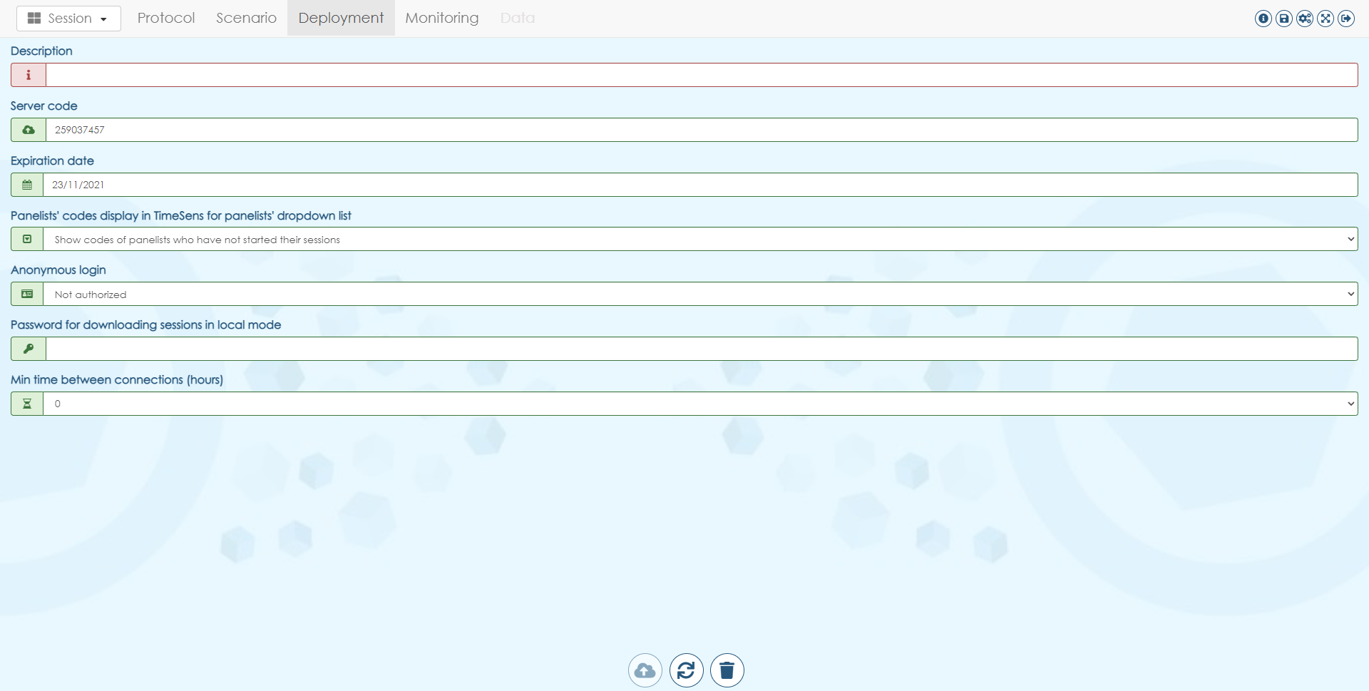

This screen displays information about the deployment:

* **Description**: optional description for the deployment
* **Server code**: code associated to the upload (the code that will be ask to the panelists along with his subject doe and password), automatically created after the session is deployed
* **Expiration date**: date on which the session will be automatically deleted on the server (see " **Delete a deployed session"**)
* **Panelists’ codes display**:
  + **Never show panelists codes**: the panelists will have to enter their codes to access the session
  + **Show codes of panelists who have not started their sessions**: the panelist will select their codes in a drop-down list, only codes of panelists with no progress in the session will be displayed
  + **Show codes of panelists who have not completed their sessions**: the panelist will select their codes in a drop-down list, all codes of panelists will be displayed (risk of simultaneous connections)
* **Anonymous login**: experimental
* **Password for local mode**: experimental
* **Min time between connections (hours):** min time required for a panelist between two access to the same session

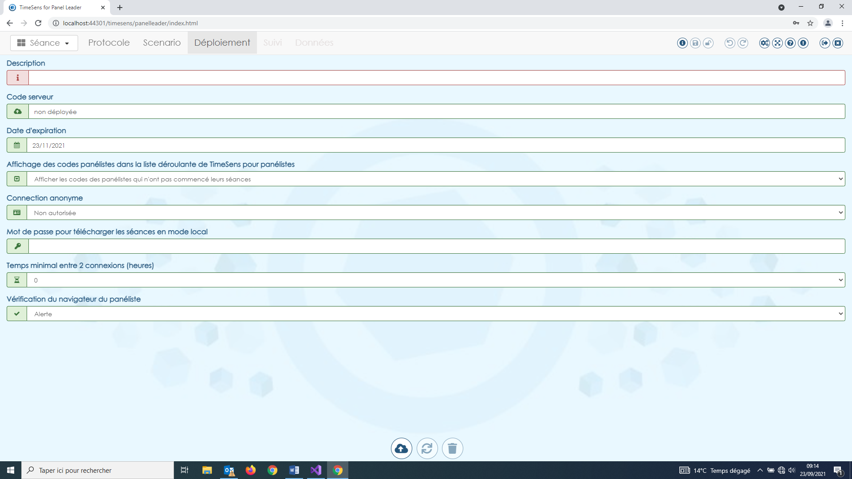

From left to right, the buttons allow to:

* **Deploy an undeployed session**
* **Update a deployed session**
* **Delete a deployed session**

## Deploy an undeployed session

This button allows to make the session available on Internet for the panelists.

**Once the session has been customized, it has to be deployed to be made accessible to panelists on the internet.**

## Update a deployed session

This button allows to update a previously deployed session.

**When changes have been made on a deployed session, the session must be updated in order to have the changes applied for the panelists. A session that has already be accessed by a panelist cannot be updated**

## Delete a deployed session

This button allows to delete a previously deployed session.

**A deleted session can no longer be assessed by the panelists and all data are removed from the server. The session itself is still available for the panel leader, as well as the data present in the data tab that have been downloaded from the monitoring tab.**

# Monitoring tab

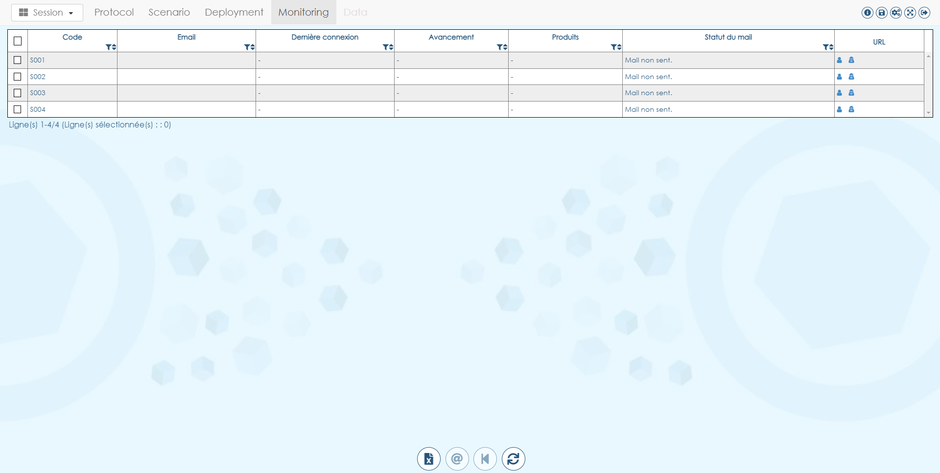

This screen displays information about the progress of the panelists in the deployed sessions:

* **Code**: panelist code
* **Email**: email of the panelist
* **Last access**: date/time of the last access of the panelist to the session
* **Progress**: current progress of the panelist
* **Products**: number of products evaluated by the panelist
* **Mail status**: status of the mail (sent/not sent)
* **URL**: URL to access the session. Clicking on the first icon allows to access to the session as a panelist, clicking on the second one icon allows to access to the session as a panel leader, with additional rights such as skipping timers and imperative answers (see below).



From left to right, the buttons allow to:

* **Export a memo**
* **Send a mail to the selected panelists**
* **Reset progress from the selected panelists**
* **Download progress**

## Export a memo

Export information about subjects (code, URL, etc.), products (codes, labels, order) and attributes (codes, labels, order) in a single multi-tabs XLSX file.

## Send a mail to the selected panelists

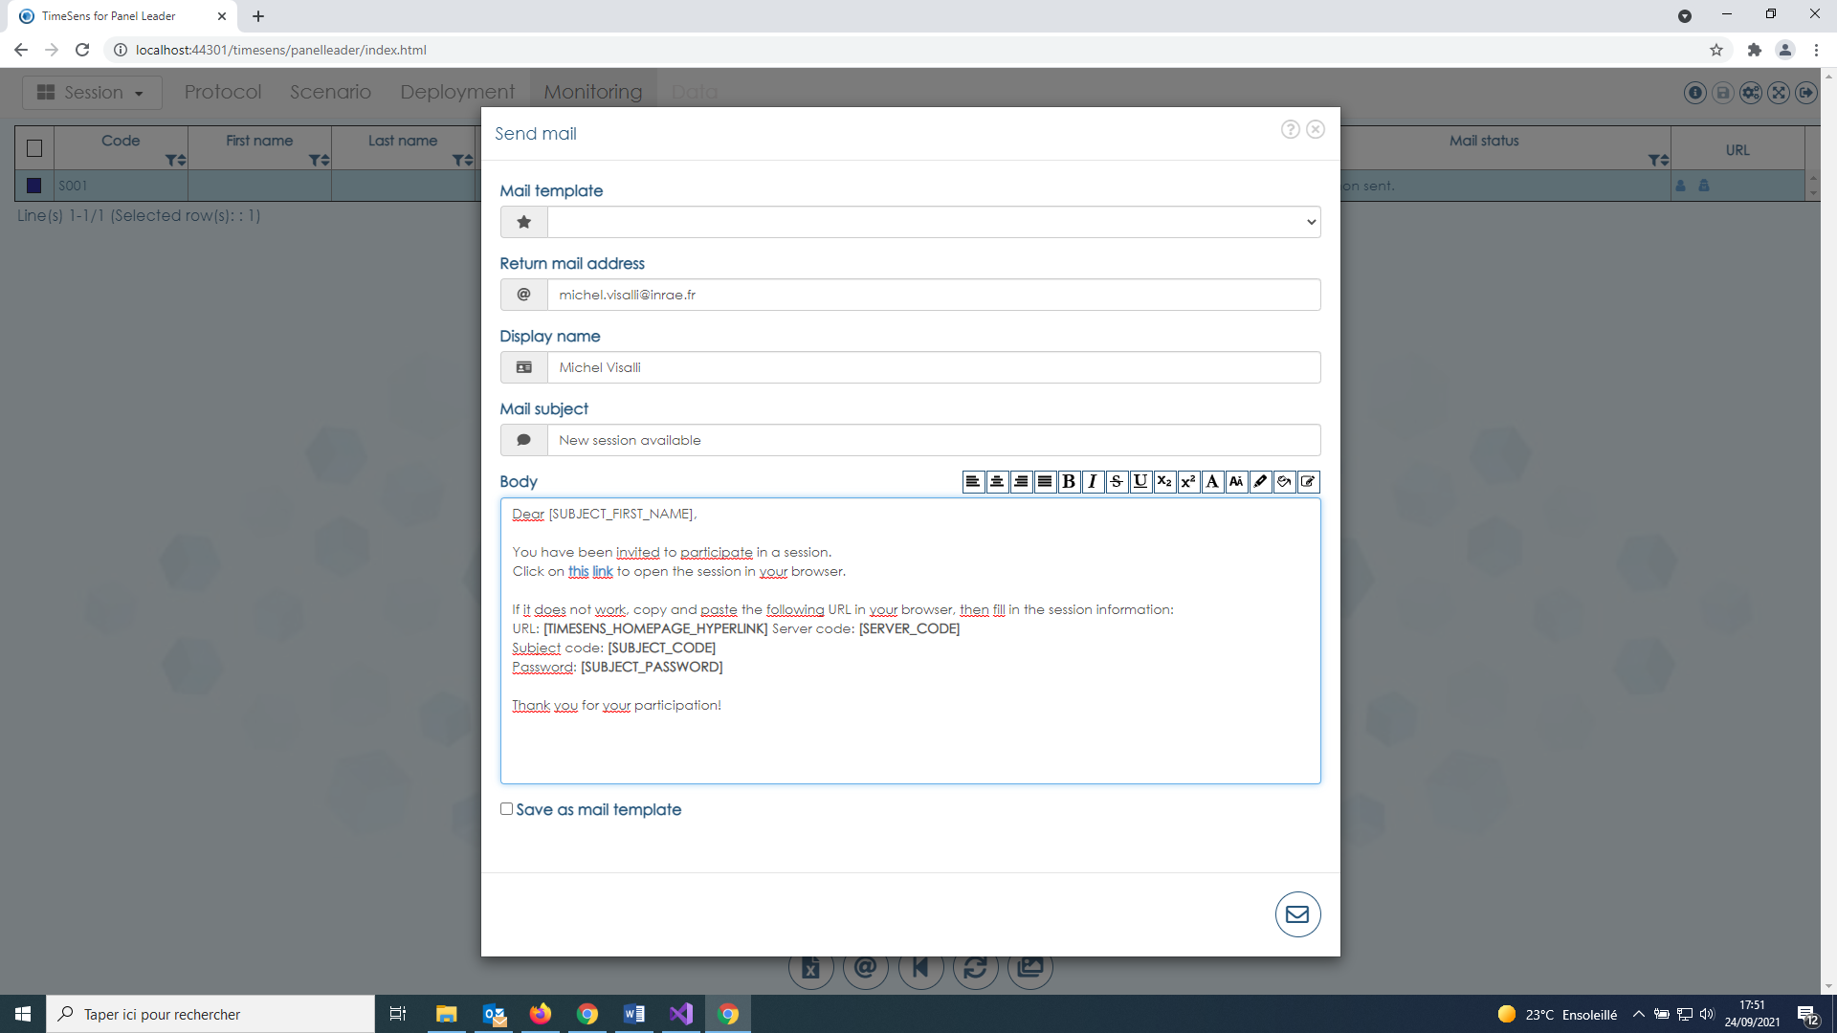

This screen allows to customize the mail that will be send to the selected panelists:

* **Mail template**: show the list of mail templates having be saved when the checkbox "Save as mail template" has been checked.
* **Return mail address**: mail address to be used when a panelist replies to a session link.
* **Display name**: name displayed in the field "from"
* **Mail subject**: text displayed in the field "subject"
* **Body**: text displayed in the body of the mail

## Reset progress from the selected panelists

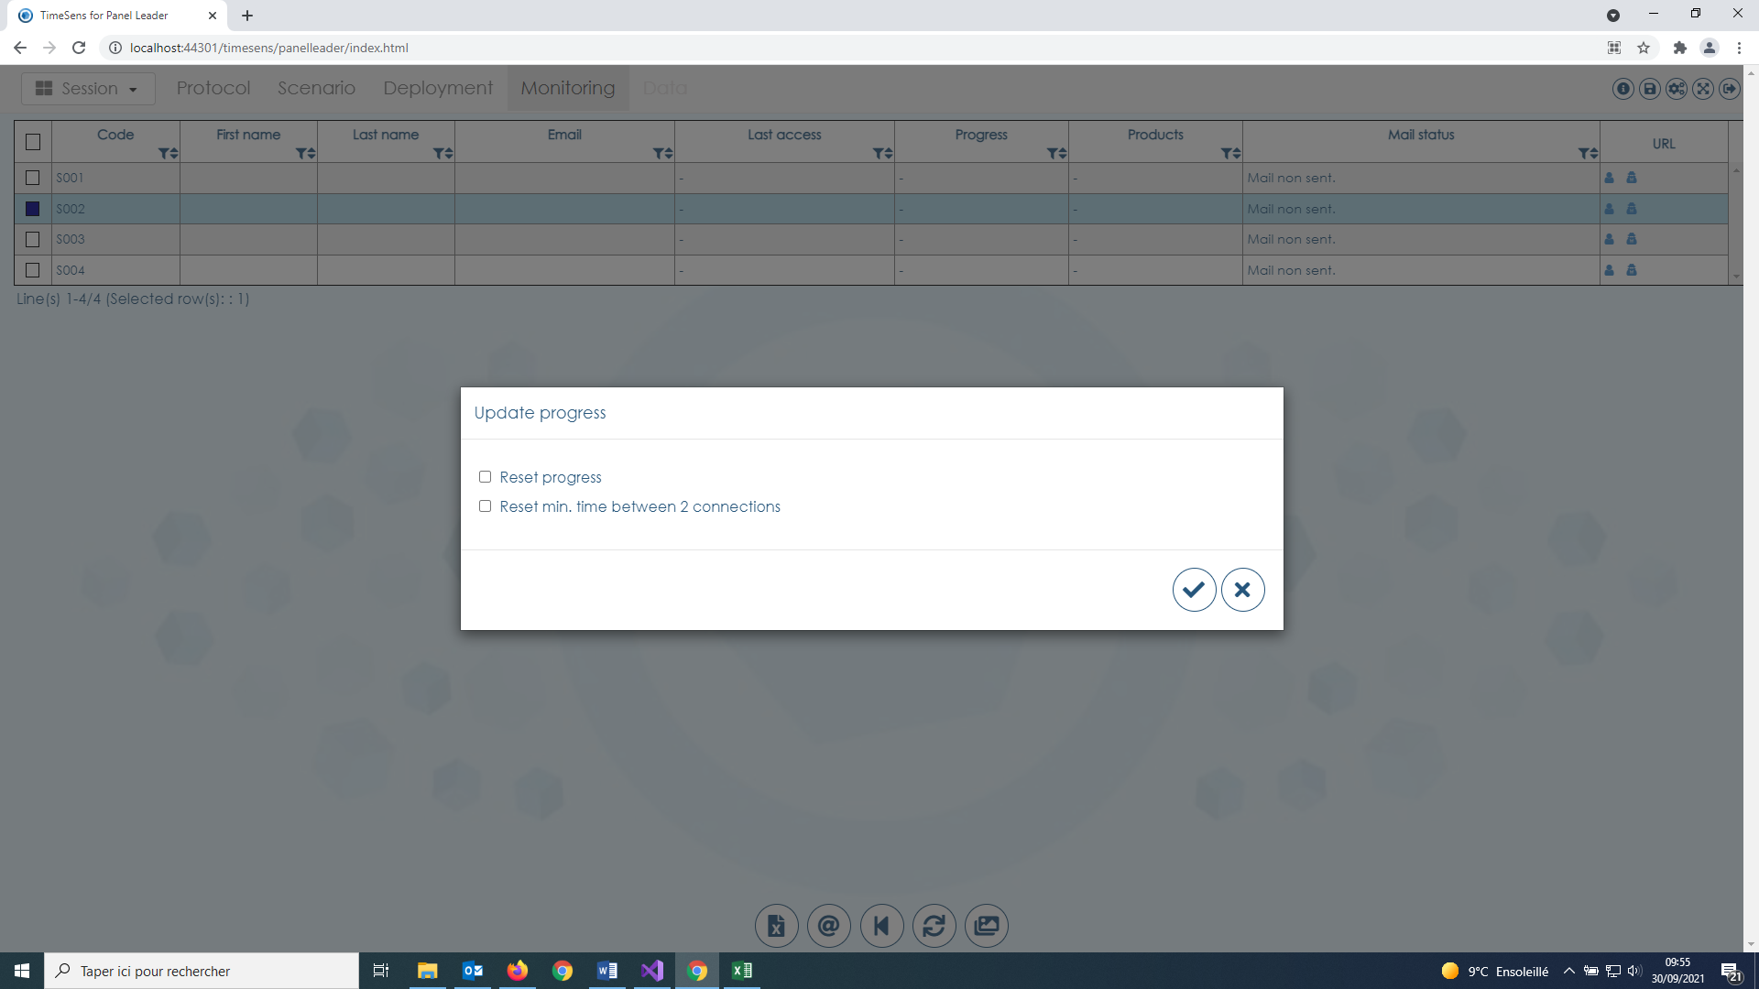

This screen allows:

* To **reset the progress of the selected panelists** (put them on the first screen of the session, discarding previous progress and data)
* And/or to **reset the minimum time between 2 connections** (as if the panelist never connected)

## Download progress

Clicking on this button allows to **refresh the progress of the panelists and to download the associated data** (that will be available in the data tab).

## access to the session as a panel leader

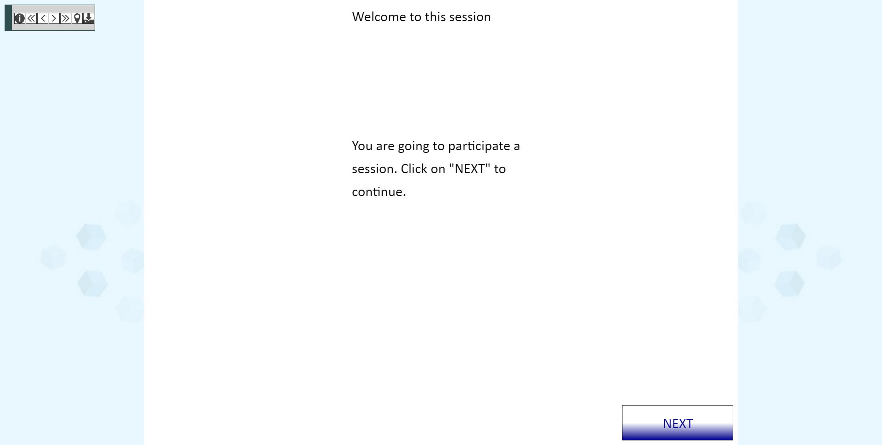

When a session is accessed as a panel leader, the buttons, from left to right, allow to:

* **Get information on the current screen**
* **Go to first screen**
* **Go to previous screen**
* **Go to next screen**
* **Go to last screen**
* **Position the panelist to the current page** (discarding his previous progress)
* **Save the session as a local file** (see TimeSens for panelists)

# Data tab

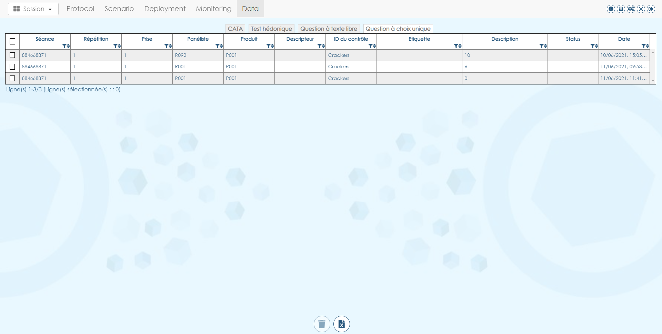

This screen displays information about the collected data, depending on the data type.

There is one tab by data type.

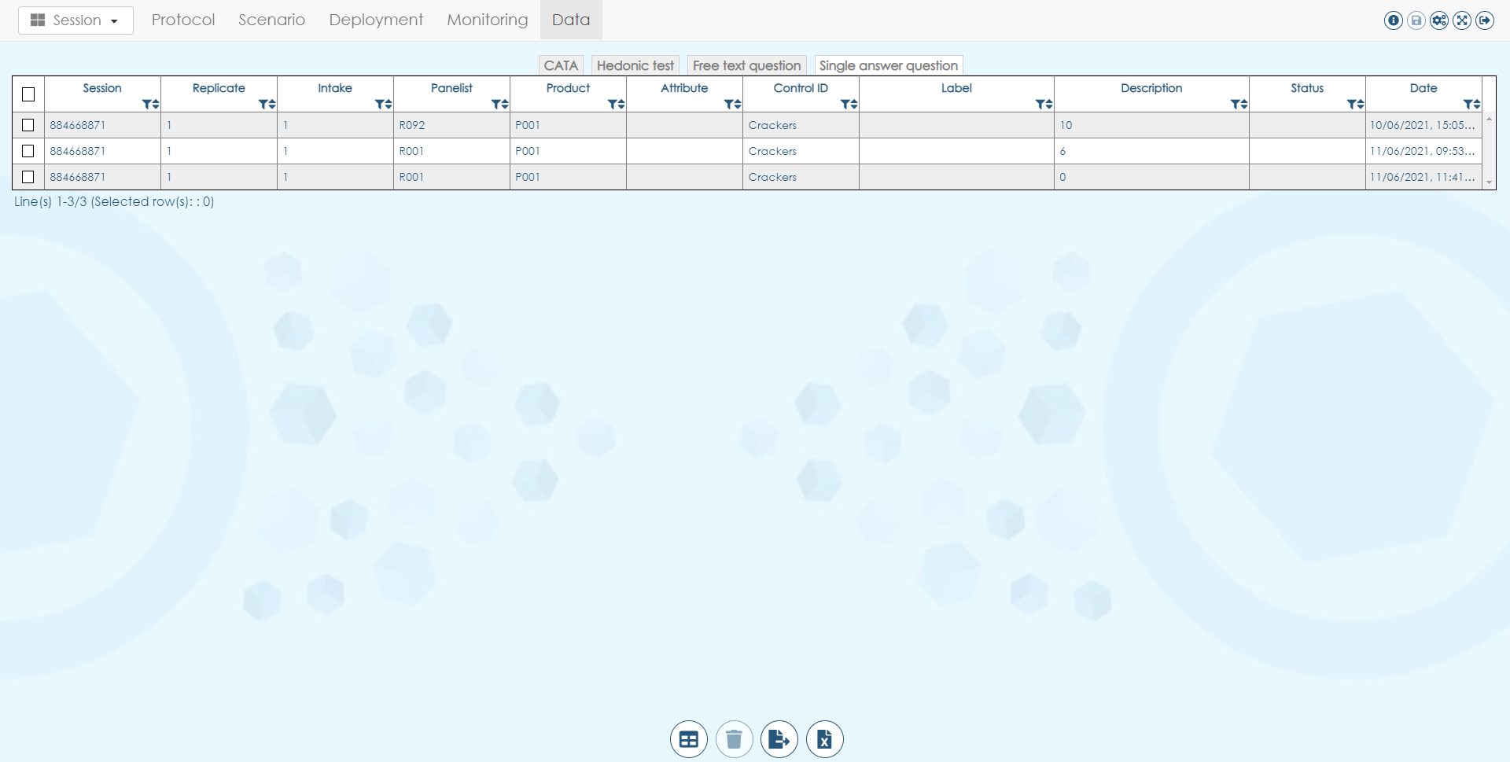



From left to right, the buttons allow to:

* **Delete selected data**
* **Export all data in an XLSX file**

Unlike TimeSens V1, there is no and **there will be no statistical analyses in TimeSens V2**.

# TimeSens for panelists

## Main screen

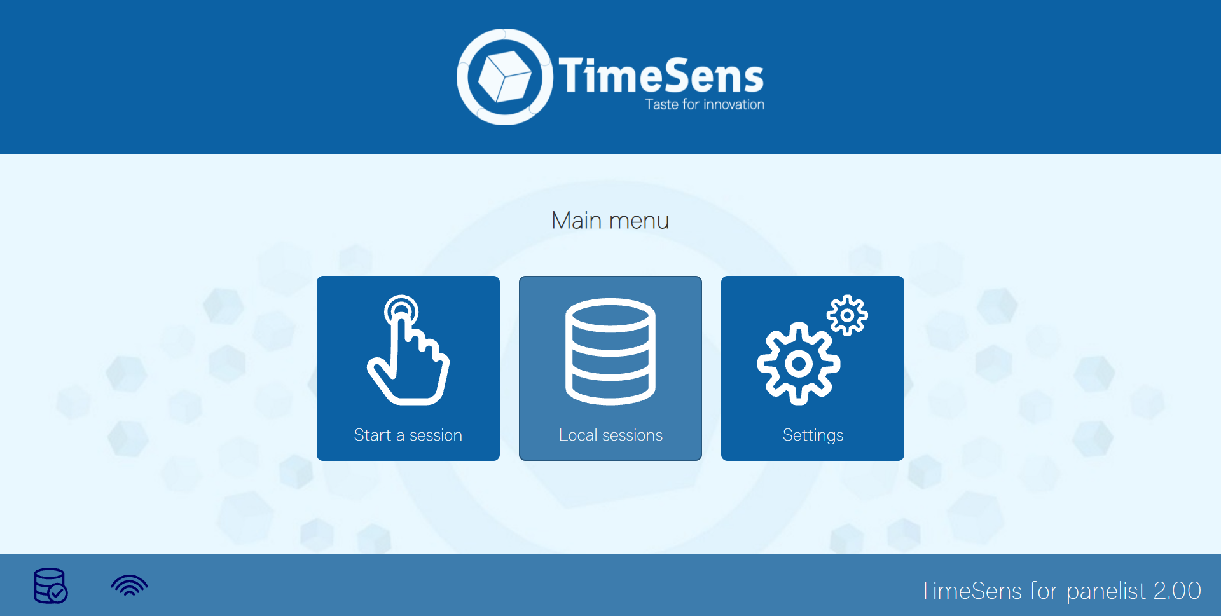

This is the main screen off the application that could be access at this URL: [**https://www.chemosenstools.com/timesens/panelist**](https://www.chemosenstools.com/timesens/panelleader)

From this screen, the panelists can start session by clicking on the corresponding button, then choosing between:

* **From code** (see below)
* **From local file** (see below)

**They can directly access to the login screen** with this URL: [**https://www.timesens.com/v2/panelist/login.html**](https://www.timesens.com/v2/panelist/login.html)

**Finally, they can directly access to the session without having to log in** by clicking on the link transmitted by the panel leader.

Example of link: https://www.chemosenstools.com/timesens/panelist /index.html?id=c2VydmVyY29kZT0yMjE1NDAxNzkmc3ViamVjdGNvZGU9UzAwMSZwYXNzd29yZD0=

**The icons at the bottom left allows to check if local database is enabled in the browser (required for starting session from local files) and to check if a network connection is available (required for starting session from code).**

## Login screen

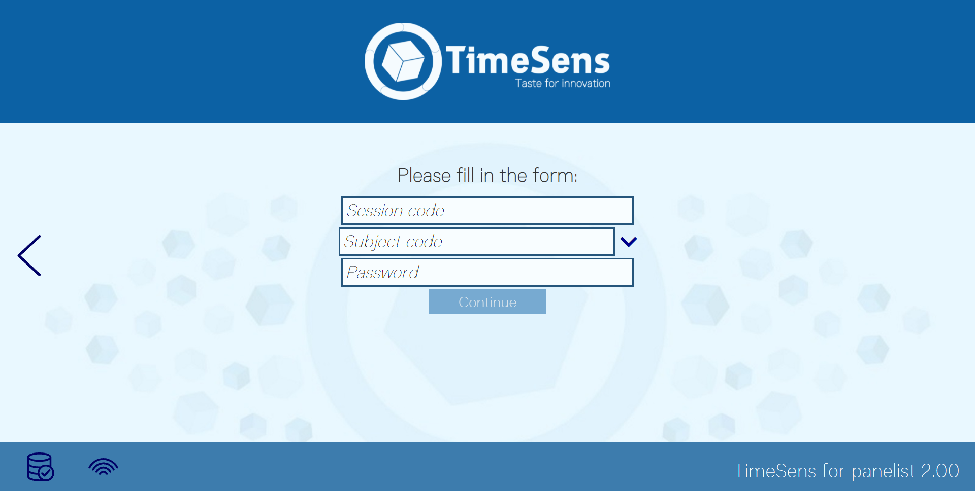

On the login screen the panelist have to enter the session code, his subject code and his password (facultative). Depending on the option chosen by the panel leader in the upload tab, the drop-down with the subject codes will be filled or not.

## Settings screen

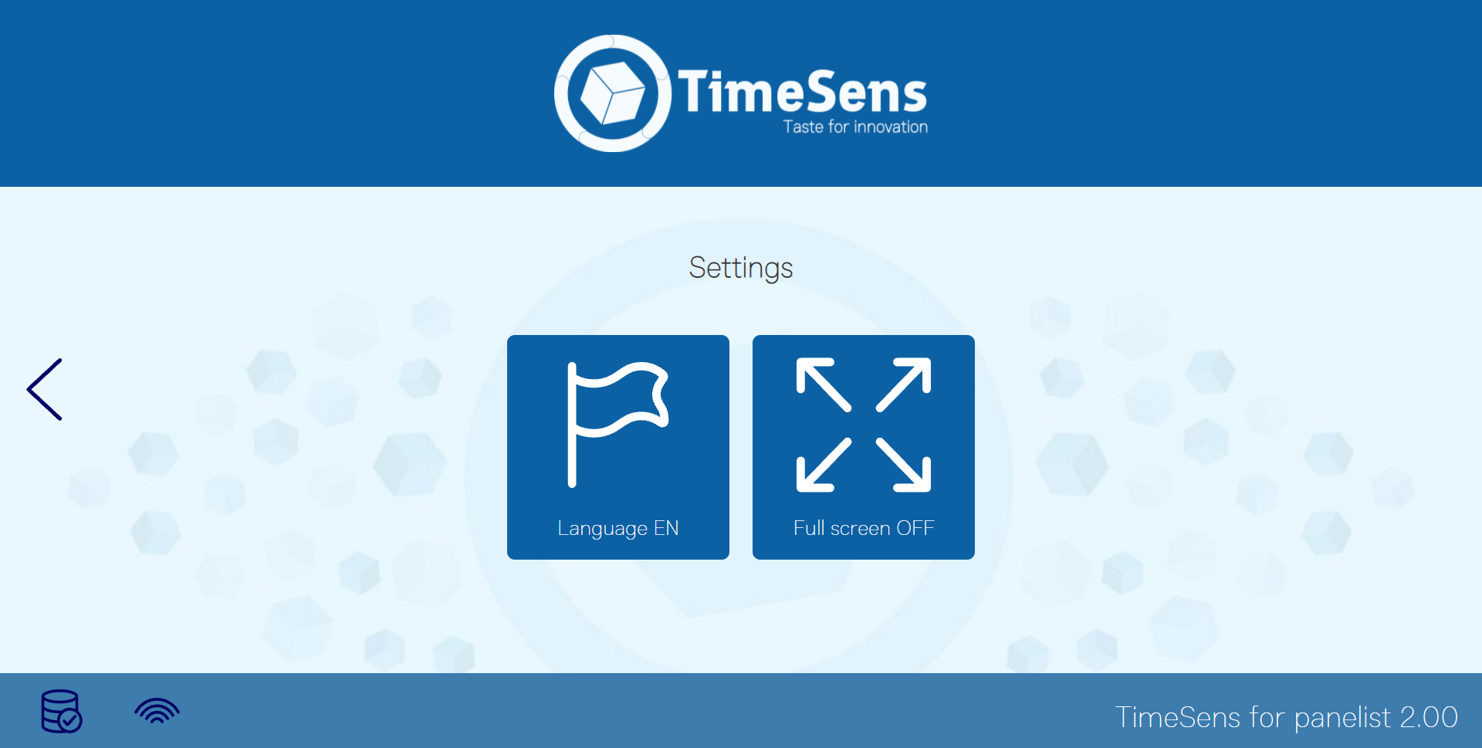

This screen allows to change the language of the application and to enable full screen mode (also activated with F11).

## Local sessions screen

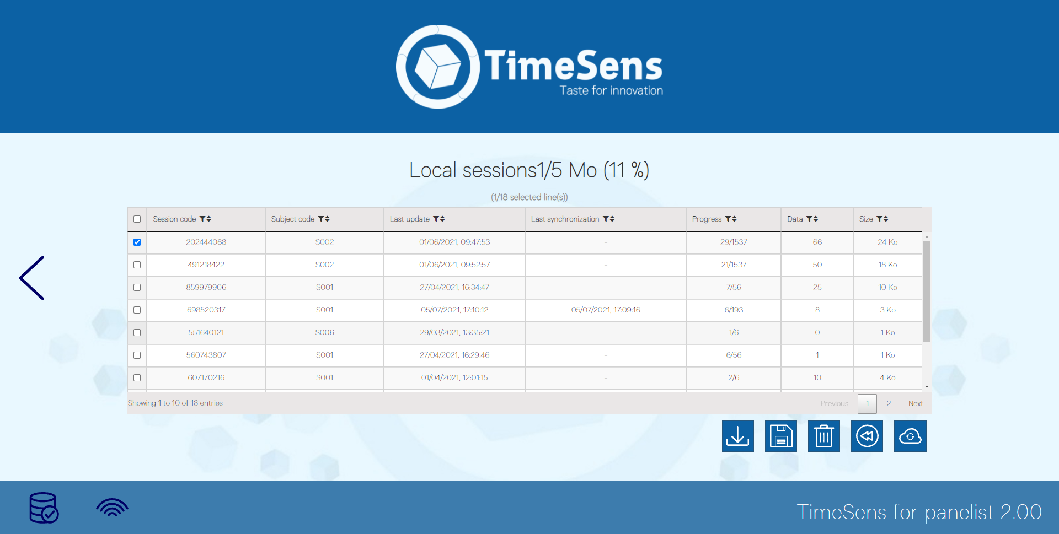

This screen enables to manage local sessions (experimental).

If local storage is enabled (depending on the browser of the panelists), all sessions are downloaded in the local storage, so they can be retrieved if a network failure occurs during a session.

The buttons at the bottom right of the table enable to:

* Download sessions from the server to be run in local mode
* Save the selected local sessions
* Delete the selected local sessions
* Reset the progress of the local sessions (discarding existing progress)
* Upload the progress to the server, making data available for the panel leader.